Albemarle County

Community Wellbeing Profile

Draft Version

May 2025

**UVA Center for Community Partnerships**

**in partnership with Albemarle County**

 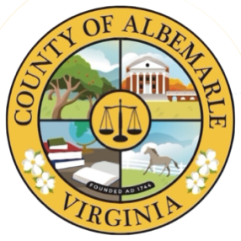

Table of Contents

Executive Summary 1

Mission Statement 3

Introduction 3

Demographic Profile 4

Race and Ethnicity 4

Age & Sex 7

Nativity & Language 8

Disability 11

LGBTQIA+ Communities 12

Policy Connections 13

Human Development Framework 15

The Human Development Index 15

AHDI and Albemarle County 16

A Long and Healthy Life: Health Profile 21

Life Expectancy 21

Food Security 23

Health Outcomes & Prevention 24

Health Insurance 27

EMS Responses to Opioid Overdoses 29

Policy Connections 30

Access to Knowledge: Education Profile 32

Degree Attainment 32

School Enrollment 34

AP & Dual Enrollment 36

Suspensions 37

Chronic Absenteeism 37

Policy Connections 38

Decent Standard of Living: Economic Security and Housing Profile 40

Earnings and Income 40

Struggling Families: Asset Limited, Income Constrained, Employed (ALICE) 43

Housing: Renters and Owners 45

Heirs’ Property in Albemarle County 51

Policy Connections 52

Additional Community Wellbeing Profiles 53

Contributors 53

The UVA Center for Community Partnerships 54

Project Repository 54

Appendix 55

AHDI Albemarle County Census Tracts 2023 vs 2019 (All Dimensions) 55

Data Sources by Figure/Table 57

## 

## Executive Summary

The Albemarle County Community Wellbeing Profile provides current data for measures related to well-being, building on the 2021 Albemarle County Equity Profile. The American Human Development Index (AHDI)—calculated from metrics on health, access to knowledge, and living standards and scored on a scale from 0 to 10—is used as a framework to assess and advocate for increased and inclusive well-being.

The AHDI for Albemarle County, at 7.3, is higher than Virginia overall, at 5.8, but lower than some benchmark localities in Northern Virginia. The 2023 AHDI is very similar to the 2019 AHDI reported in the prior profile. Given the intervening crisis of COVID-19, this stability was not a given.

|  |  | Health | Access to Knowledge | | | | Living Standards |
| --- | --- | --- | --- | --- | --- | --- | --- |
| **American HD Index** | Life Expectancy (years) | At Least High School Diploma | At Least Bachelor’s Degree | Graduate Degree | School Enrollment | Median Earnings |
| Local | | | | | | | |
| Albemarle (2023) | **7.3** | 82 | 94% | 61% | 31% | 85% | $51,922 |
| Albemarle (2019) | **7.4** | 83 | 95% | 61% | 30% | 87% | $44,030 |
| State | | | | | | | |
| Virginia (2023) | **5.8** | 78 | 91% | 41% | 18% | 76% | $49,405 |
| Virginia (2019) | **5.8** | 79 | 90% | 40% | 17% | 78% | $40,405 |
| Data Sources: *Life Expectancy:* County Health Rankings, 2024. *Education and Earnings:* U.S. Census Bureau, American Community Survey 5-year estimates, 2023. | | | | | | | |

While each component of the AHDI remained quite stable between the 2019 and 2023 profiles, a few of the additional measures included in the profile changed in small but notable ways. Among measures of health, the percent of residents experiencing food insecurity grew from 8% in 2019 to 10% in 2023. Among education-related measures, the percent of students who were chronically absent nearly doubled from 7% in 2019 to 13% in 2023; this increase mirrors post-COVID increases seen nationally. Among indicators of living standards, the percent of households that are asset-limited, income-constrained and employed declined from 37% in 2019 to 30% in 2023. No other measures showed noteworthy changes between the two reports.

Census tract-level AHDI values provided in this profile show that there are wide disparities in outcomes related to health, education, and economic success within Albemarle County.

Life expectancy at birth is high in Albemarle, at 82 years, however, there are major demographic disparities: a 5-year difference between Black and white residents. The percent of residents without health insurance ranges within the county, with most census tracts falling below 10% and others as high as 20% and 31%. There are also stark disparities by racial and ethnic identity, with 3% of white residents, 8% of Black residents, and 27% of Hispanic residents lacking coverage.

Overall, educational attainment is high in Albemarle County: 61% of residents overall have a bachelor’s degree or higher. Among county census tracts, this value ranges from 37% to 86%. Additionally, there are differences in degree attainment by race and ethnicity: 31% of Black residents, 36% of Hispanic residents, and 65% of white residents have BA’s or higher.

The median household income for Albemarle is high, around $102,600 a year—the value for which half of households bring in more and half bring in less. Across the county, median household income ranges from a low of $41,000, to a high of $183,000. Many households with incomes below the local cost of living threshold, but above the federal poverty line may not be traditionally thought of as financially burdened. The cost of living, for Albemarle County has increased over the past decade. In 2010, this threshold for survival was $50,000 for households under 65; this grew to $78,000 in 2022. Overall, 9% of households in Albemarle are earning incomes below the federal poverty line and 30% of families earn above this amount but below cost of living threshold, meaning they struggle to afford their basic needs.

These and other measures and outcomes presented in the Albemarle County Community Wellbeing Profile are a resource for residents and leaders to support understanding of our collective well-being and point to challenges we can address together. Each section of the report—Demographic Profile, Health Profile, Education Profile, and Economic Security and Housing Profile—also include key policy connections, highlighting research and policy choices that support universal well-being.

## Mission Statement

Albemarle County’s stated mission is to enhance the well-being and quality of life for all community members through the provision of the highest level of public service consistent with the prudent use of public funds.[1]

Enhancing the well-being of all community members requires ensuring the full inclusion of all residents in the collective economic, social, and political life of the community. An inclusive community values every individual's rights and labor and celebrates our diverse cultures and experiences to support shared prosperity and thriving.

## Introduction

Ensuring the full inclusion of residents in the social, economic, and civic life of a region supports the long-term health and vibrancy of a community. The systems of education, employment, housing, and health care affect all residents, but they do not always promote well-being for all residents. An inclusive community is one in which all individuals—regardless of their racial, ethnic, religious, gender, or sexual identity, their age or place of birth, their economic circumstances or neighborhood of residence—can access resources and opportunities that advance health, civic participation, and economic security.

Knowing how a community stands is a first step. This report, in partnership with Albemarle County builds on the 2021 Albemarle County Equity Profile to provide an updated data portrait of Albemarle County. Centered around the American Human Development Index, the Community Wellbeing Profile provides a framework and insights to support the community’s efforts to promote a more inclusive and just region. It serves as a tool for government agencies and officials, for service providers and community organizations, for advocates and residents to guide plans, policies, and programs that advance our collective welfare.

Each section of the report—Demographic Profile, Health Profile, Education Profile, and Economic Security and Housing Profile—provides measures disaggregated by place and by race. Data can spark dialogue, guide strategy, and gauge progress, but it is not a solution. It is up to the stakeholders in the community—that is, all of us—to change policies, practices, and power that shape the community. Thus, each section also highlights key policy connections, pointing to past policies that exacerbate inequity and highlighting policy choices that support universal well-being. An inclusive community actively works to recognize and dismantle unjust barriers to the resources and systems that support health, education, financial stability, physical security, and democratic participation.

## Demographic Profile

A locality’s demographic composition can reflect the area’s past and current policy choices, inform the diverse needs of different community members, and provide insight into the region’s cultural inclusivity. The profile begins by examining the population attributes of the estimated 117,790 county residents.[2]

### Race and Ethnicity

Albemarle County has witnessed significant demographic shifts over its history. Some of these changes have been documented by the U.S. Census, which began collecting population data in 1790 with limited categories that included “free white” people and enslaved populations. Other racial and ethnic populations have not been captured in the statistics tracked by the US government, including the presence of the Monacan people, who have lived in the area for at least 1,000 years. This omission reflects systemic efforts to erase the presence and impact of Native people.[3]

Between the decennial census years of 1810-1880, Black Virginians, both free and enslaved, comprised much of the population of Albemarle County, which included what is now the City of Charlottesville. The City of Charlottesville became a separate locality after its incorporation in 1888. In this period the demographics of the region shifted in their racial composition. By 1900, the majority of the county’s population was white (Figure 1.1).

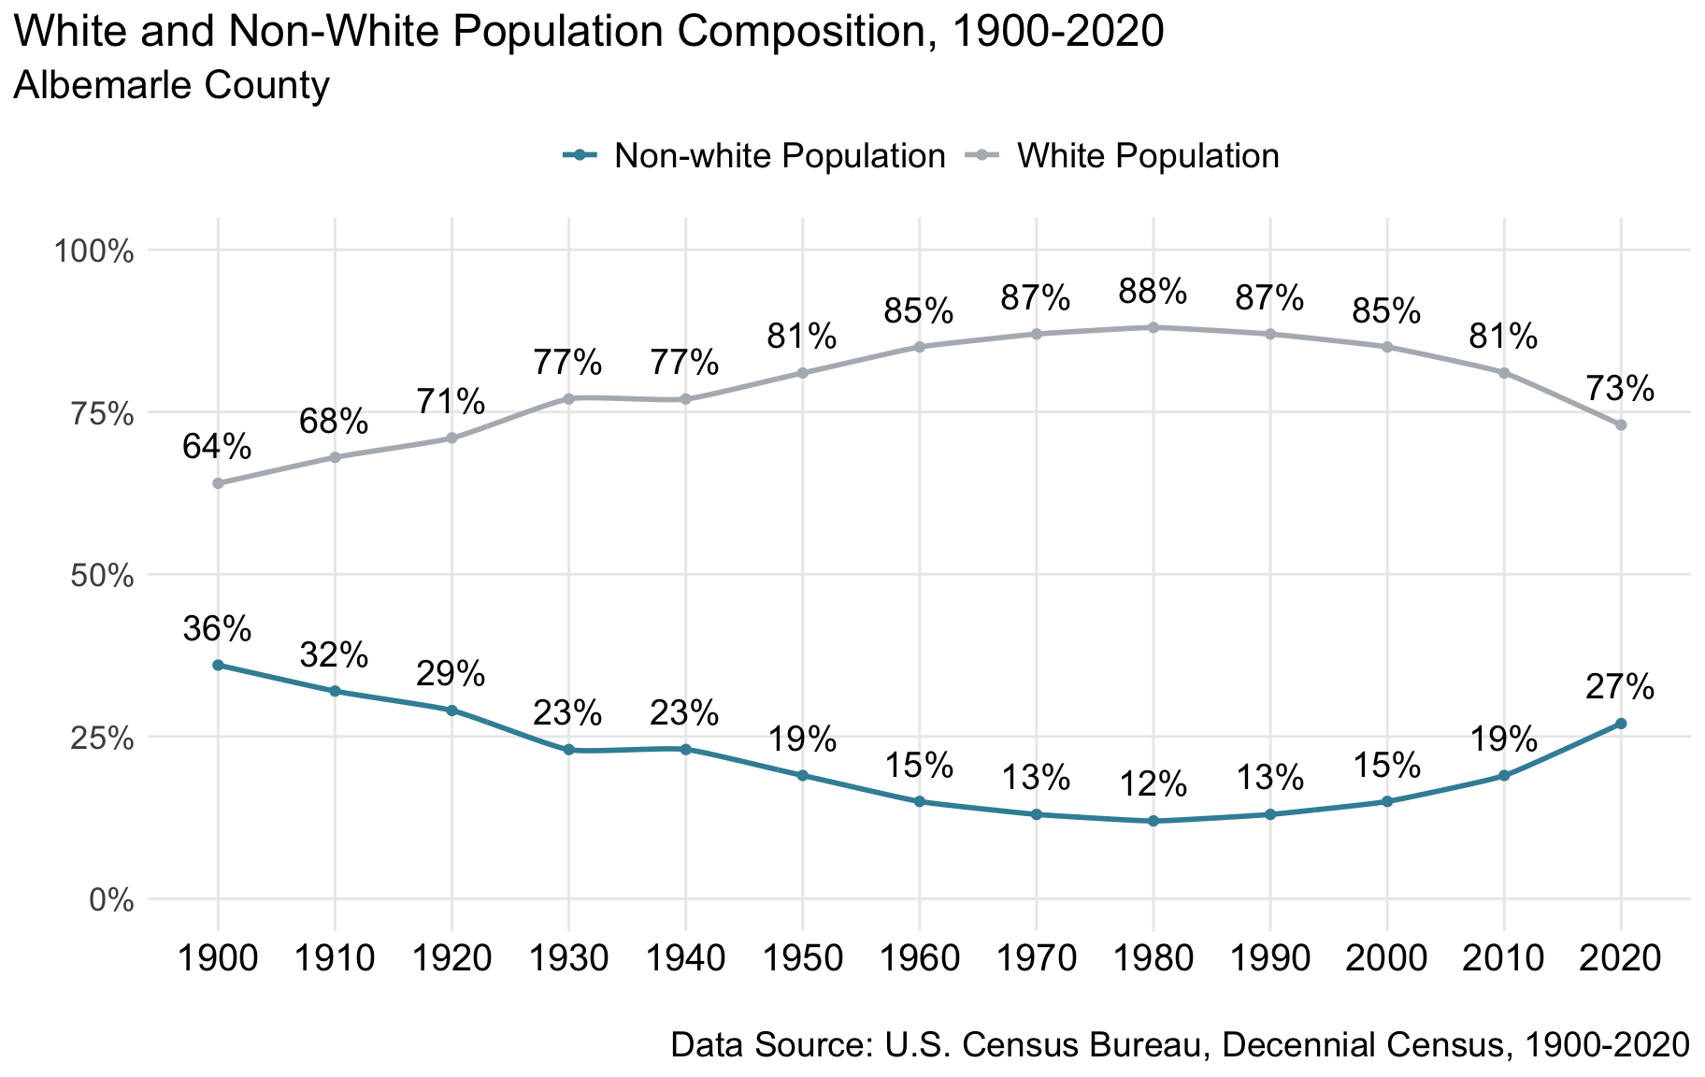

Figure 1.1: White and Non-White Population Composition, 1900-2020. White residents have made up a majority of the population of Albemarle over the past century, peaking at 88% in 1980. Inherent limitations of and inconsistencies across historical census data collections require simplifying long-term population trends into ‘white’ and ‘nonwhite.’

As the population of Albemarle has grown—from approximately 28,500 residents in 1900 to 112,400 residents in 2020—the county’s demographics have undergone multiple transitions. The first half of the 20th century saw Albemarle’s population shift as Black residents migrated out of the region to pursue greater economic opportunities and escape Jim Crow-era policies that arose in the American South. These policies worked in opposition to Reconstruction and enforced the status quo through violence and dispossession.[4]

Even so, Black Virginians established several thriving communities in Albemarle County after emancipation. One such community was Proffitt, which was established in 1871 by Benjamin Brown and John Coles, two formerly enslaved men who purchased the land from a former slaveholder.[5] This community expanded in the following decade with the arrival of more emancipated men and women, and received a dedicated post office and railroad depot in 1881, increasing the area’s commercial status.[6] By the early 1900s, Proffitt had firmly established its cultural and economic importance to the Albemarle region. Today, Proffitt is listed on the National Register of Historic Places, and the community retains connections to its historically significant past. Evergreen Baptist Church was established in Proffitt in 1891 and remains a site of historical and cultural importance to this day.

While the racial identification of Albemarle’s population remains predominantly white, Albemarle today is more multi-racially and culturally diverse.

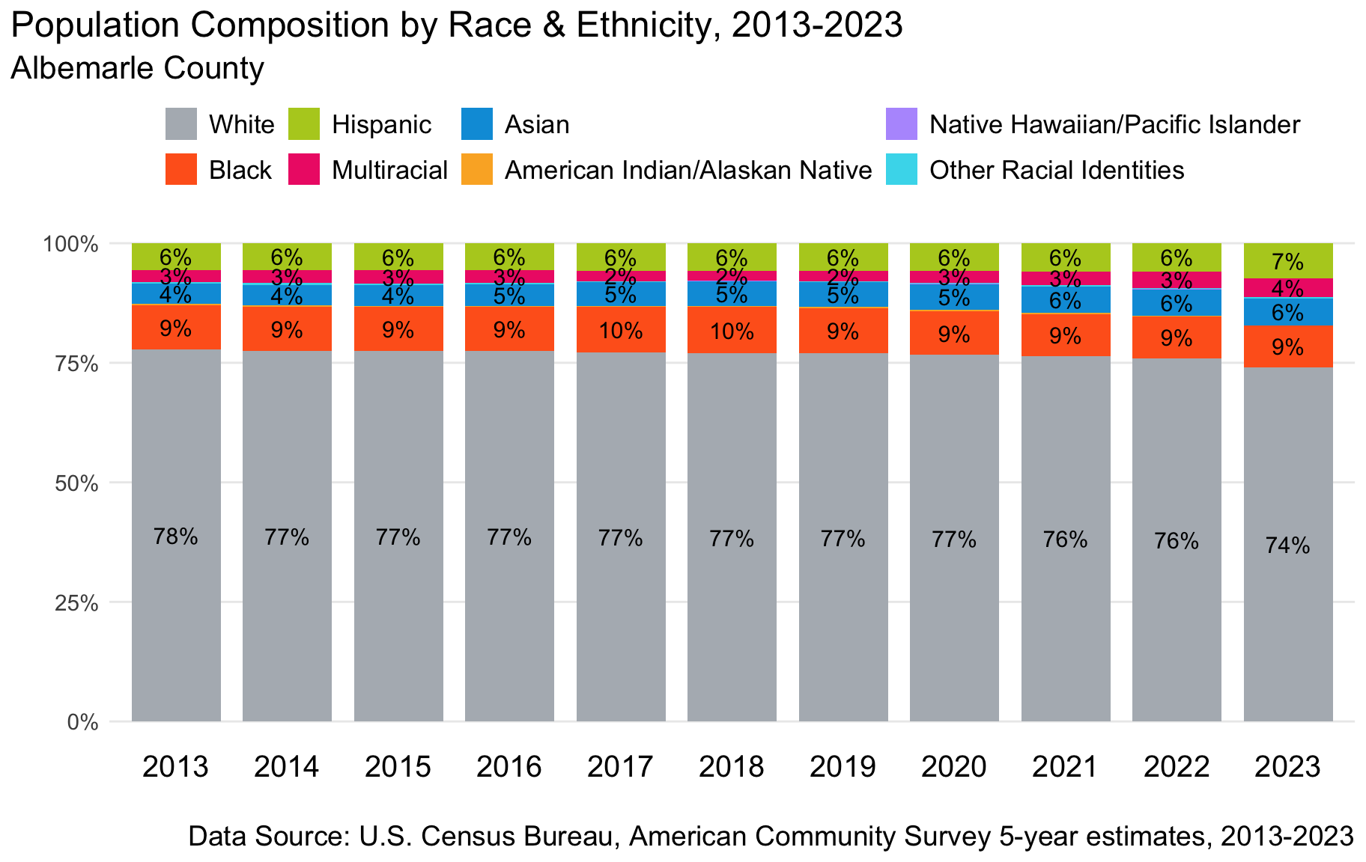

Figure 1.2: Population Composition by Race & Ethnicity, 2013-2023. According to US Census data, in 2023 74% of residents identified as White, 9% as Black or African American, 6% as Asian, 7% as Hispanic or Latino, and 4% as Multiracial. Less than 1% identified as American Indian/Alaskan Native, Native Hawaiian/Pacific Islander, or an other racial identity.

The above figure shows that over the past decade, the racial and ethnic identities of Albemarle’s residents have remained relatively unchanged. During this period, the county’s population grew from around 100,600 residents in 2013 to approximately 113,700 in 2023.[7] White residents make up nearly three-quarters of the county’s population (74%), with Black residents comprising approximately 9% of the population, followed by Hispanic (7%) and Asian (6%) residents.

To fully understand the data reported here, it is important to consider the ways that race and ethnicity is defined and captured by the U.S. Census. Grouping communities using broad racial categories is, by nature, reductive and often fails to capture the full breadth of individuals’ self-identities. Racial and ethnic categories are always socially constructed, that is, they derive their power through practices of racial stratification and the social conditions it creates. The change in what racial categories are captured over time highlights the social and political nature of the categorizations.[8] The analysis that follows is inherently limited by the current practice in defining race and ethnicity, mandated by the federal government and within the U.S. Census as well as state and local records. As the Census itself states, the racial categories used for data-collection are based on race as it is socially defined in the United States and not on a definition of race as biological or genetic.[9] The Federal Interagency Working Group on Race and Ethnicity Standards works to update the racial and ethnic categories and questions, including a proposal to include a future category for Middle Eastern and North Africa (MENA).[10] We acknowledge that definitions of racial identity reflect structures of oppression and domination, and inform ongoing histories of violence and marginalization.

### Age & Sex

The population of Albemarle County has grown slightly older in the past decade, reflecting a broader trend in Virginia’s rural counties.[11]

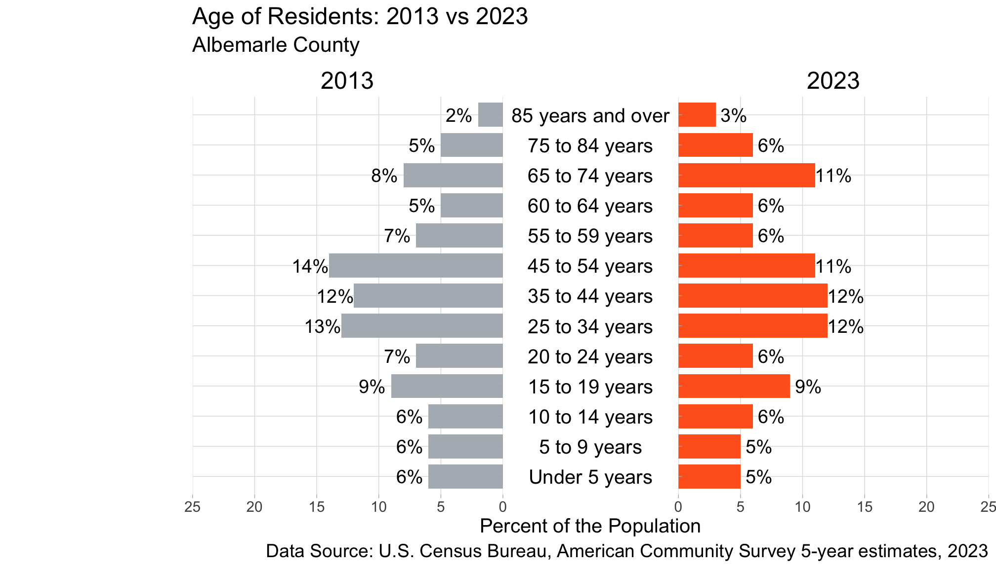

Figure 1.3: Age of Residents: 2013 vs 2023. In 2023, 25% of county residents were under 20 years, 30% were between 20 and 44 years, 23% were 45-64 years, and 20% were 65 years and older.

* In 2023, approximately 35% of residents were in the 25-54 age range.
* In the last decade, the age of Albemarle’s population has been relatively stable: the percentage of residents under the age of 25 has slightly dropped from 34% in 2013 to 31% in 2023.
* From 2013-2023, the share of Albemarle’s population aged 65 or older has increased, from 15% to 20%.

The population in Albemarle is evenly split between residents identifying as female and male.[12] This can be seen across all age groups (Figure 1.4).

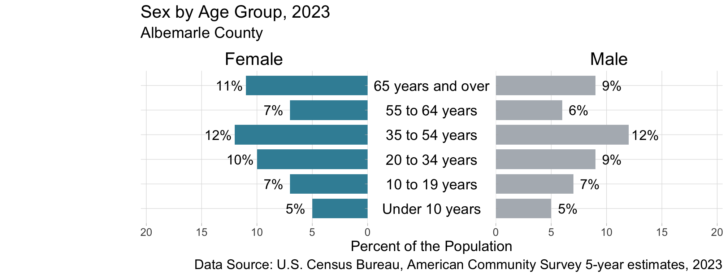

Figure 1.4: Sex by Age Group. In the US Census American Community Survey, 2023, 52% of residents identified as female and 48% identified as male.

### Nativity & Language

New residents to Albemarle who were born outside of the United States make invaluable contributions to the county’s culture, economy, and regional identity. This group of residents, composed of both naturalized citizens and non-US citizens, make up 10% of the county’s population (Figure 1.5).

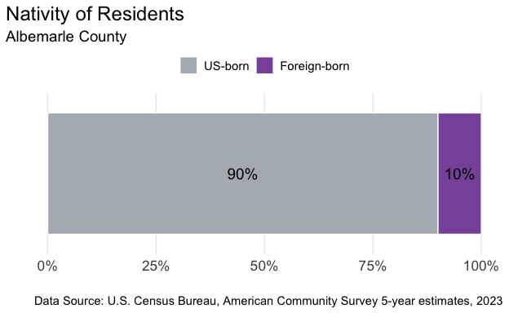

Figure 1.5: Nativity of Residents. In 2023, 10% of residents were born outside of the United States, including naturalized citizens. 90% of residents were born in the US, in US territories, or born abroad of American parents.

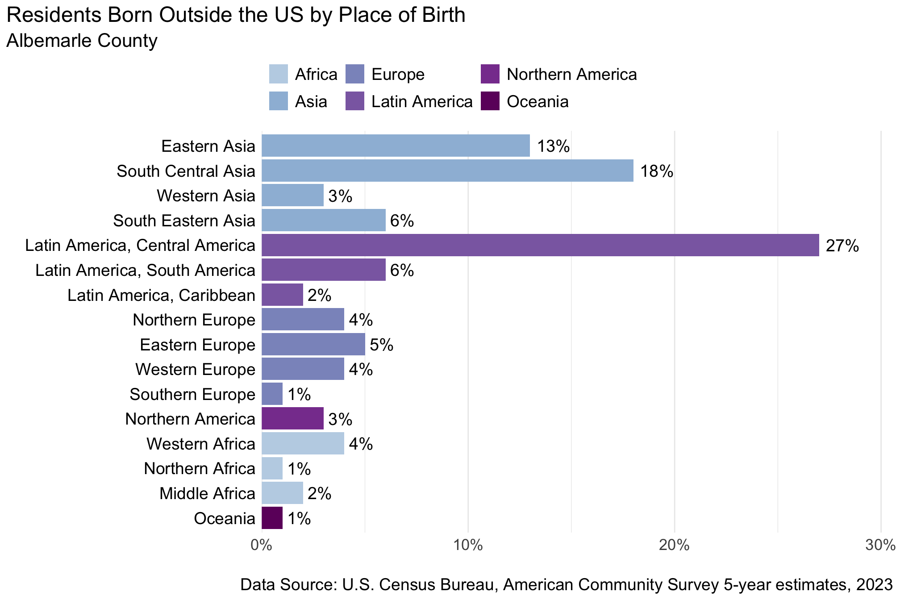

Figure 1.6: Residents Born Outside the US by Place of Birth, 2023. Of foreign-born residents, 40% were born in Asia, 35% Latin America, including Mexico as part of Central America, 15% Europe, 3% Northern America, 7% Africa, and 1% Oceania.

Of the residents born outside the United States, 40% have immigrated from Asia: a broad classification that includes the diverse regions of Eastern Asia, South Central Asia, Western Asia, and South Eastern Asia. Latin America is the second largest place of origin represented among Albemarle’s residents born outside of the U.S (35%), another large category that encompasses the Caribbean, South America and Central America, including Mexico.[13]

Linguistic isolation limits the accessibility of critical services for new residents. The U.S. Census Bureau defines linguistic isolation, or limited English speaking, as households where no one age 14 or older speaks English proficiently.[14] In 2023, 2% of Albemarle households were ‘limited English speaking’, which amounts to over 1,000 households who would benefit from policies that improve access to critical services like housing, transportation, and healthcare (Figure 1.7).

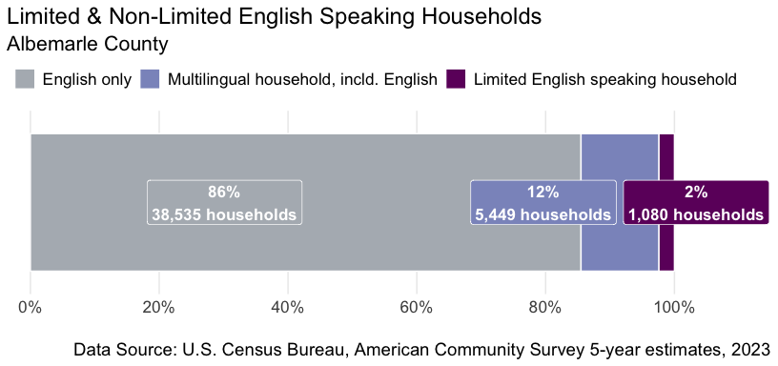

Figure 1.7: Limited & Non-Limited English Speaking Households, 2023. 86% of households speak only English, 12% of households are multilingual including English, and 2% are limited English speaking households.

A range of language groups are spoken by multilingual Albemarle families, with Spanish being the most common (Figure 1.8). The largest number of “limited English speaking” households speak primarily Spanish (688 families), Chinese (140 families), and other Indo-European languages (116), which include most languages of Europe and the Indic languages of India such as Hindi, Punjabi, and Urdu.

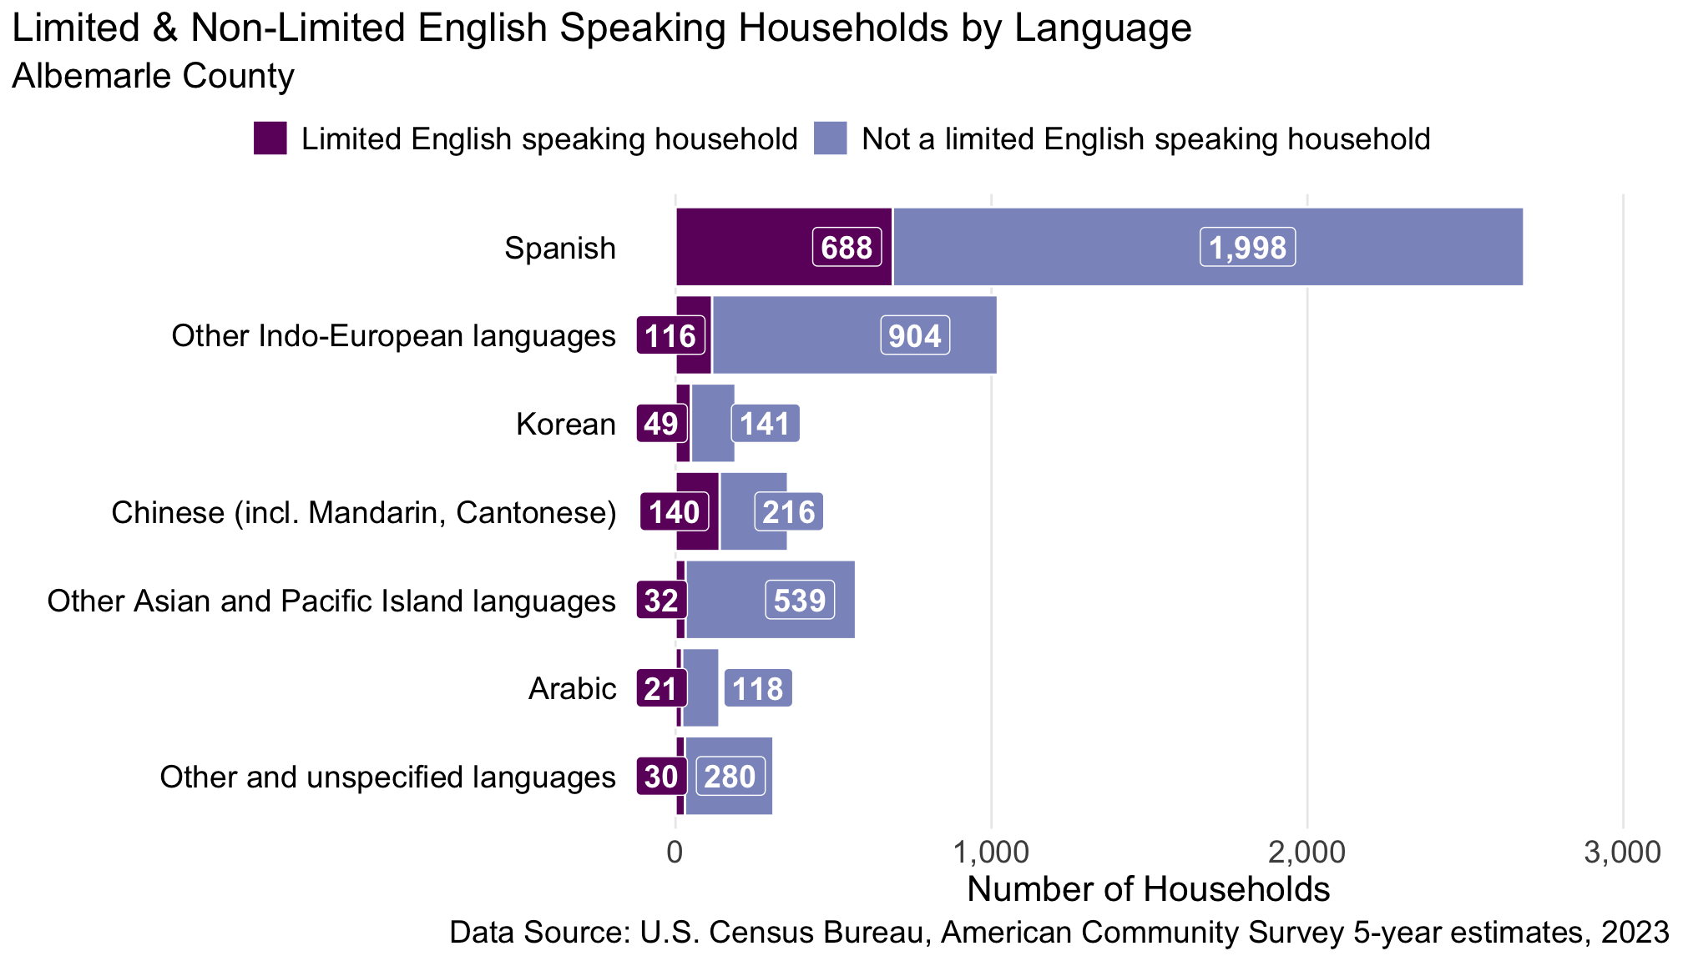

Figure 1.8: Limited & Non-Limited English Speaking Households by Language, 2023. Of the approximately 1,080 linguistically isolated households, 688 speak Spanish, 140 Chinese (incl. Mandarin, Cantonese), 21 Arabic, 49 Korean, 32 Other Asian and Pacific Island languages, 116 Other Indo-European languages, 30 Other and unspecified languages.

### Disability

Approaching policy, planning, and infrastructure with the intent to maximize access for people with disabilities can create more equitable and functional cities for all residents.

* Nearly 10% of Albemarle’s population identifies as having a disability.[15]
* One quarter (25%) of residents aged 65 and over experience some form of disability (Figure 1.9).
* The most commonly reported disabilities are those often associated with aging: ambulatory and cognitive difficulties and challenges with living independently (Figure 1.10).
* Contemporary approaches to administering federal surveys may be systematically undercounting people with disabilities, so the true number is likely higher.[16]

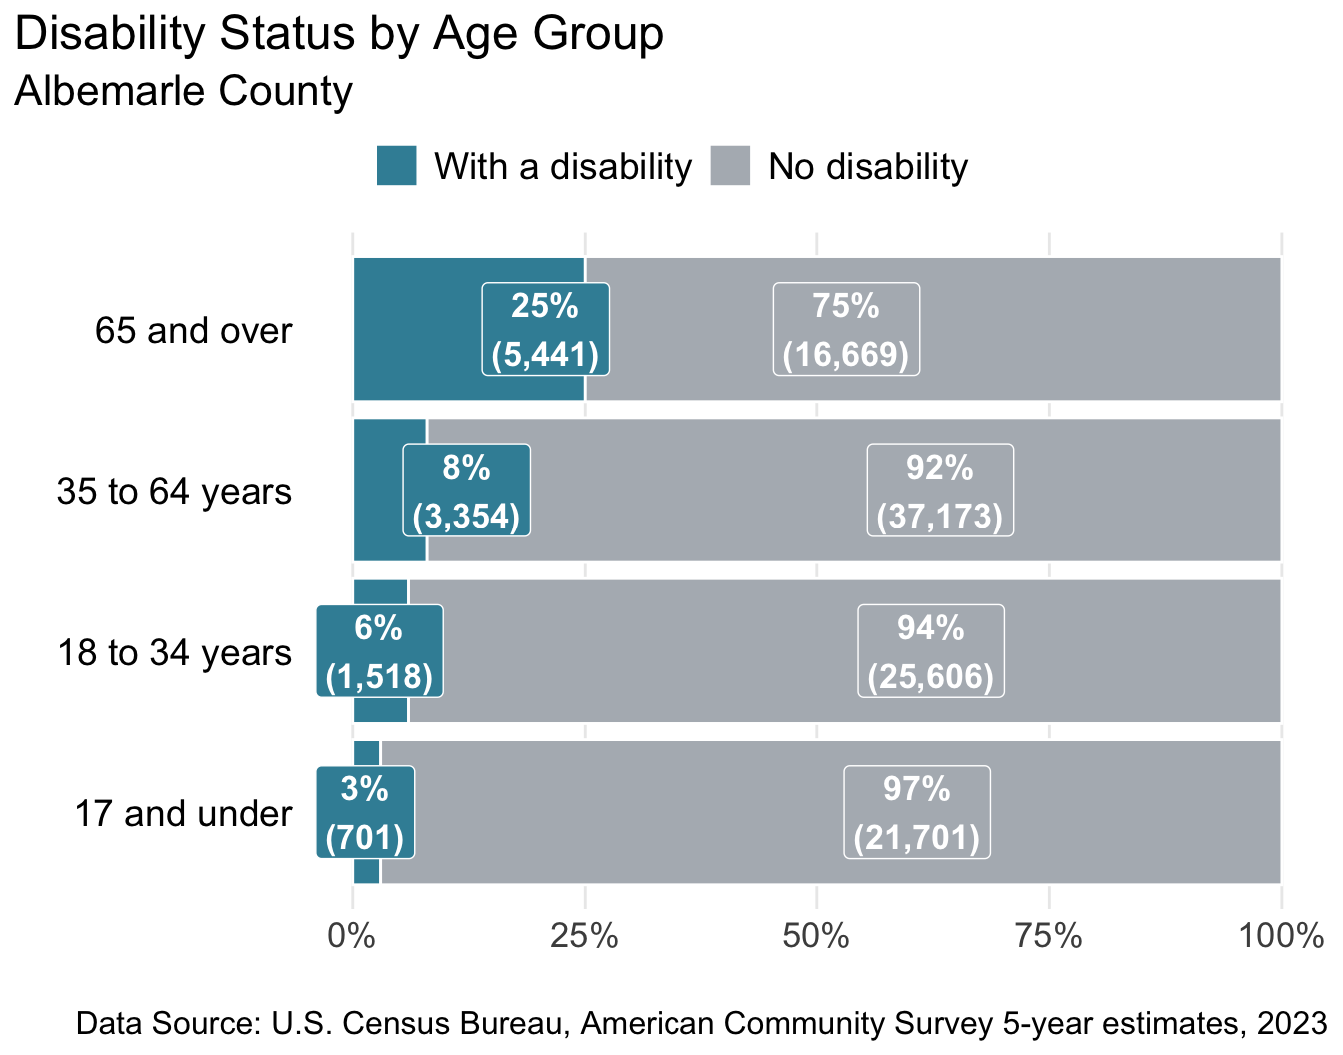

Figure 1.9: Disability Status by Age Group, 2023. Approximately 11,014 people identify as having a disability, with over half of those aged 65 and older (5,441 people).

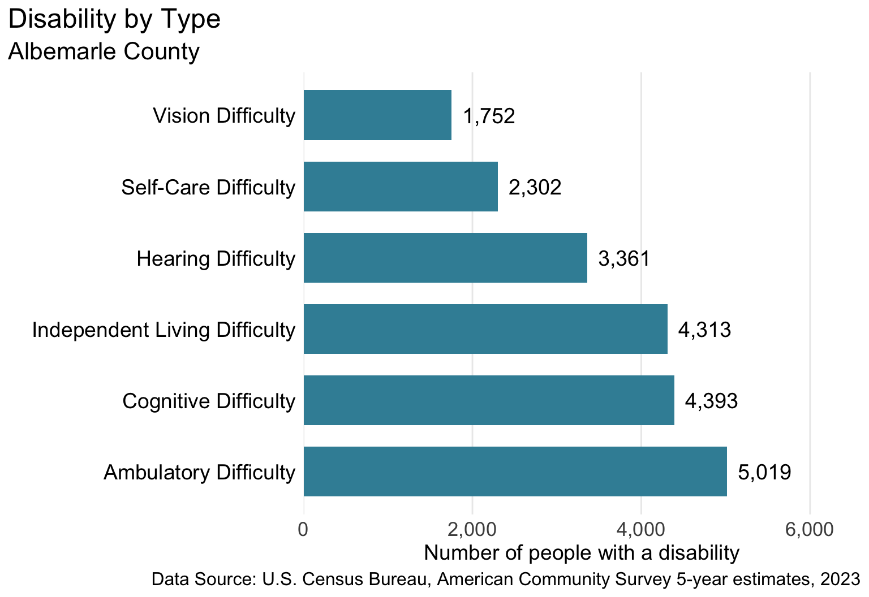

Figure 1.10: Number of people identifying as having a particular disability. Census-defined categories and the number of people include hearing difficulties (3,361), vision difficulties (1,752), cognitive difficulties (4,393), ambulatory difficulties (5,019), self-care difficulties (2,302), and independent living difficulties (4,313).

### LGBTQIA+ Communities

Albemarle County’s LGBTQ+ population is a vital part of the region’s culture and identity. As part of their efforts to increase awareness, the Albemarle County Office of Equity and Inclusion published an interactive learning resource about gender and sexual orientation.[17]

Across Virginia, the estimate of adults who identify as lesbian, gay, bisexual or trans ranges from 6% to 10%.[18] Same-sex couple households, which comprise only a small portion of LGBTQ+ individuals, make up about 1.4% of all coupled households in Albemarle; across the Commonwealth, same-sex couple households make up 1.4% of coupled households.[19]

More granular, locality-level data on LGBTQ+ populations in the United States is very limited, partly as a result of the American Community Survey largely excluding LGBTQ+ topics from its data collection process to date.[20] The Census Bureau has engaged in research directed at adding questions on sexual orientation and gender identity to the American Community Survey in the future.[21]

### Policy Connections

To create policies and programs that invest in people, we need to understand who we are as a community and how the community is changing. Albemarle County’s ongoing growth involves balancing its expanding urban ring with the rural characteristics treasured by residents of all backgrounds.

As Albemarle County added 13,100 more residents between 2013 and 2023, demographically the majority of growth was among White residents (60% of the increase). Asian and multi-racial residents accounted for another 16% and 12% of the growth, respectively. Hispanic residents made up only 10% of the increase, and Black residents made up only 3% of the population’s growth. As the county’s population continues to grow, ensuring development of more and more affordable housing will ensure a diverse population can afford to call the county home. Incorporating approaches like racial equity impact assessment tools into policy making can strengthen racial diversity and inclusion and shape decisions throughout government to promote universal thriving.[22]

The county has seen a growth in the number of residents over 65 in the last decade. Older Americans are more likely to experience social isolation, and difficulty accessing transportation.[23] Access to spaces in their immediate communities that support active social engagement—so-called “third places,” such as parks, community centers, and welcoming businesses—has positive health effects for older populations while supporting vibrant social infrastructure for all community members.[24] Aging residents, too, may face growing challenges to driving: alternative transportation options can promote well-being and support continued engagement in the community.[25]

Older people living in rural and suburban regions in the US consistently struggle with infrastructural impediments to safety and mobility. Individuals of any age with a disability experience additional barriers in health care, housing, employment, and education.[26] Incorporating universal design principles to make spaces accessible to all people, regardless of mobility limitations, benefits everyone.[27] Areas that prioritize vehicles and lack proper sidewalks, lighting, and safe crossings, on the other hand, create additional challenges for people with disabilities while decreasing safety for pedestrians of all ages. Simple interventions like raised crosswalks can improve pedestrian visibility and reduce crashes by 45%.[28] Albemarle County’s Americans with Disabilities Act (ADA) Coordinator’s Office actively works to ensure that county services and resources are accessible to community members with disabilities.[29]

The vibrancy of Albemarle is enhanced by new residents from other countries. Several hundred Albemarle households meet the Census criteria for “limited English speaking” status. Language barriers impede social integration and create difficulties navigating education, health care, and legal systems.[30] Language access through translation of written documents and interpretive services ensure that critical information is accessible to new residents, and is required by programs and agencies receiving federal funding.[31] Foreign-born families, though, may avoid applying to government assistance programs out of concerns related to how their information will be shared.[32] Support for residents in obtaining the new state driver’s privilege cards or state-issued identification cards can help new residents be part of the community with less fear.[33] Prohibiting the participation of local law enforcement with Immigration and Customs Enforcement further supports the integration and involvement of new residents.[34]

## Human Development Framework

### The Human Development Index

The Human Development Index (HDI) [35] is a metric that assesses the distribution of well-being along three axes: health, access to knowledge, and living standards. As an alternative to money metrics like GDP (Gross Domestic Product), the HDI measures basic indicators of human welfare, going beyond measures of income or economic growth. The first HDI presented in 1990 is now used around the globe to gauge country-level quality of life. Governments in many countries use the HDI as an official statistic, employing this data to launch conversations about how to promote policies that will enhance opportunity and well-being for all people.

In addition to illuminating facets of well-being not captured in economic metrics, the HDI appropriately reflects the interconnectedness of many different sectors: health, education, housing, and more. Human well-being is influenced by multiple factors that cannot be isolated from one another, and the HDI captures several of these at once. In this way, the HDI mirrors the social determinants of health, a framework that recognizes the way health and well-being is shaped by the conditions in which we live.[36] By looking at the full spectrum of people in our community, the HDI promotes an inclusive view, one in which we can all see ourselves.[37]

This report employs an adapted version of the HDI, the American Human Development Index (AHDI), which was created by Measure of America of the Social Science Research Council to be relevant at sub-national geographic levels such as states and counties. The AHDI utilizes the same components of the HDI—health, access to knowledge, and living standards—but adapts them to a local American context characterized by the conditions of an affluent democracy.

### AHDI and Albemarle County

Using the methodology developed by Measure of America, each component of AHDI—health, access to knowledge, and living standards—is scored on a 0 to 10 scale for a specific geography.[38] The AHDI is the average of these three scores: each component carries equal weight in the index as all carry equal importance for community well-being.

The health component is calculated using life expectancy at birth. Access to knowledge uses two measures: educational attainment and school enrollment. Educational attainment combines the percentage of the population aged 25 years and older who have earned at least a high school diploma or equivalent, at least a bachelor’s degree, or an advanced degree (master’s, professional, doctoral, etc.). School enrollment is the percentage of the population between the ages of 3 and 24 that are currently enrolled in a public school, private school, college or university. The living standards component of the AHDI is calculated using median personal earnings.

Table 1 shows AHDI for Albemarle County, the City of Charlottesville, Virginia overall, and other localities that serve as comparative benchmarks:

**Table 1:** **American Human Development Index: Comparison Across Benchmark Localities**

|  |  | **Health** | **Access to Knowledge** | | | | **Living Standards** |
| --- | --- | --- | --- | --- | --- | --- | --- |
| **American HD Index** | Life Expectancy (years) | At Least High School Diploma | At Least Bachelor’s Degree | Graduate Degree | School Enrollment | Median Earnings (2023 $) |
| **Local** | | | | | | | |
| Albemarle | 7.3 | 82 | 94% | 61% | 31% | 85% | $51,922 |
| Charlottesville | 6.2 | 79 | 93% | 61% | 33% | 87% | $38,285 |
| **State & US** | | | | | | | |
| Virginia | 5.8 | 78 | 91% | 41% | 18% | 76% | $49,405 |
| United States | 5.3 | 78 | 89% | 35% | 14% | 76% | $44,587 |
| **Benchmark Counties** | | | | | | | |
| Fairfax | 8.4 | 85 | 93% | 64% | 32% | 81% | $71,572 |
| Fauquier | 6.3 | 80 | 92% | 40% | 15% | 78% | $55,904 |
| Hanover | 6.2 | 78 | 94% | 42% | 16% | 80% | $53,394 |
| Loudoun | 8.6 | 84 | 94% | 64% | 28% | 84% | $82,579 |
| Montgomery | 5.7 | 79 | 96% | 48% | 26% | 90% | $32,364 |
| Prince William | 6.6 | 81 | 90% | 44% | 18% | 77% | $57,337 |
| Roanoke | 5.8 | 78 | 94% | 37% | 13% | 77% | $48,688 |
| Arlington | 8.9 | 85 | 95% | 77% | 41% | 74% | $88,306 |
| Data Sources: *Life Expectancy:* County Health Rankings, 2024. *Education and Earnings:* U.S. Census Bureau, American Community Survey 5-year estimates, 2023. | | | | | | | |

The AHDI for Albemarle County is higher than Virginia overall, but lower than some benchmark localities in Northern Virginia.

The 2023 AHDI is very similar to the 2019 AHDI reported in the inaugural Albemarle County Equity Profile. Table 2 shows the AHDI values for Albemarle County and Virginia overall for 2023 compared to 2019. Given the intervening crisis of COVID-19, this stability was not a given.

**Table 2:** **American Human Development Index: 2023 vs 2019**

|  |  | **Health** | **Access to Knowledge** | | | | **Living Standards** |
| --- | --- | --- | --- | --- | --- | --- | --- |
| **American HD Index** | Life Expectancy (years) | At Least High School Diploma | At Least Bachelor’s Degree | Graduate Degree | School Enrollment | Median Earnings |
| Albemarle (2023) | 7.3 | 82 | 94% | 61% | 31% | 85% | $51,922 |
| Albemarle (2019) | 7.4 | 83 | 95% | 61% | 30% | 87% | $44,030 |
| Virginia (2023) | 5.8 | 78 | 91% | 41% | 18% | 76% | $49,405 |
| Virginia (2019) | 5.8 | 79 | 90% | 40% | 17% | 78% | $40,405 |
| Data Sources: *Life Expectancy:* County Health Rankings, 2024. *Education and Earnings:* U.S. Census Bureau, American Community Survey 5-year estimates, 2023. | | | | | | | |

Within the county, there are large differences in AHDI across neighborhoods. That is, people are experiencing different outcomes in their health, education, and living standards depending on where they live. Figure 2.1 shows the AHDI for each census tract. Census tracts are areas determined by the U.S. Census Bureau to approximate neighborhoods; they are roughly equal in population and are bounded by major roads, rivers and railroad tracks.

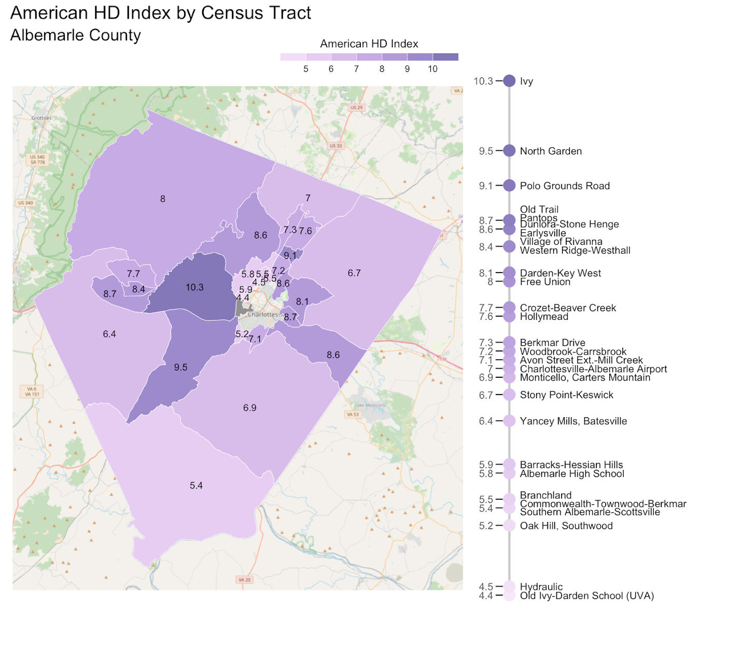

Figure 2.1: American Human Development Index by Census Tract. In Albemarle, the AHDI varies significantly across different neighborhoods, ranging from 4.4 to 10.3.

The disparities in the map are clear. Several tracts have an AHDI around five: Oak Hill/Southwood (5.2), and Hydraulic (4.5). Old Ivy-Darden School (UVA) has the lowest score in the county of 4.4, which can be impacted by the student housing prevalent in this tract. At the high end, Ivy carries an AHDI of 10.3, followed by North Garden, with a score of 9.5.

To better understand the nature of these discrepancies, Figure 2.2 shows the value for each individual AHDI component—health, education, and income—by census tract. Some tracts, such as Ivy and North Garden, experience uniformly high values across each component, while others, such as Hydraulic, experience uniformly lower values across each component.

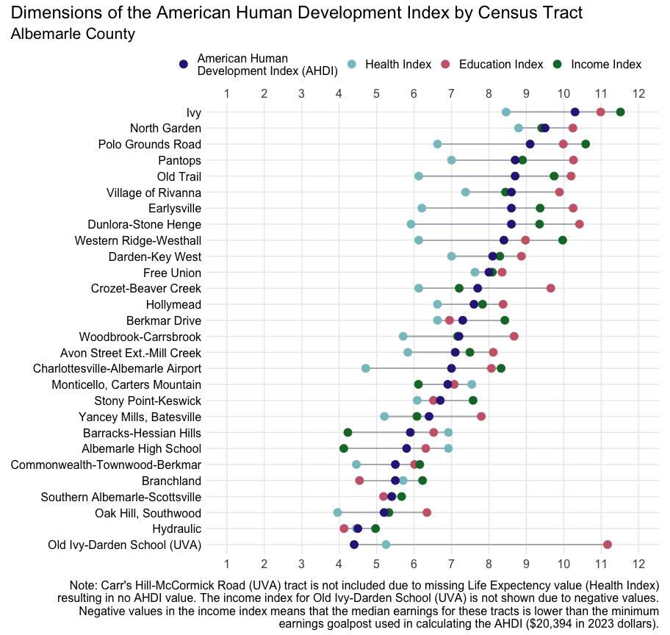

Figure 2.2: Dimensions of the American Human Development Index by Census Tract. The health, education, and income indices are averaged to make the AHDI.

Neighborhoods like Old Ivy-Darden School (UVA) have a wide gap between their AHDI components, with high values in their education index and low values in earnings. Some of this can be explained by the student housing prevalent in this tract, as students tend to make low wages while being enrolled full time at the University. However, focusing solely on the income of postsecondary students can obscure the pervasive poverty among non-student residents.[39]

Table 3 shows changes in tract-level AHDI from 2019 to 2023. Following the 2020 Census, new tracts were created due to increases in the area’s population. As seen in the table below, six of the tracts from 2019 were split into two or three tracts for 2023, making direct comparisons for these areas challenging. In nearly all tract boundaries that remained the same, the ADHI measure increased between 2019 and 2023. The biggest differences occur when tracts were split, suggesting that the larger 2019 tract combined neighborhoods experiencing diverse conditions. The 2019 tract that contained Albemarle High School, however, saw declines in the AHDI among both of the 2023 tracts that were previously part of the common tract.

**Table 3:** **American Human Development Index: Albemarle County Census Tracts 2023 vs 2019**

| Census Tract (2023) | Tract Name (2023) | AHDI 2023 | AHDI 2019 | Tract Name (2019) | Census Tract (2019) |
| --- | --- | --- | --- | --- | --- |
| 101 | Free Union | 8.0 | 7.2 | Free Union | 101 |
| 102.01 | Charlottesville-Albemarle Airport | 7.0 | 6.3 | Charlottesville-Albemarle Airport | 102.01 |
| 102.02 | Earlysville | 8.6 | 8.2 | Earlysville | 102.02 |
| 103.01 | Berkmar Drive | 7.3 | 7.1 | Hollymead | 103 |
| 103.02 | Polo Grounds Road | 9.1 |
| 103.03 | Hollymead | 7.6 |
| 104.01 | Stony Point-Keswick | 6.7 | 5.8 | Stony Point and Keswick | 104.01 |
| 104.02 | Village of Rivanna | 8.6 | 7.8 | Village of Rivanna | 104.02 |
| 105.01 | Darden-Key West | 8.1 | 7.7 | Pantops | 105 |
| 105.02 | Pantops | 8.7 |
| 106.03 | Branchland | 5.5 | 5.7 | Branchland to Carrsbrook | 106.01 |
| 106.04 | Woodbrook-Carrsbrook | 7.2 |
| 106.02 | Dunlora-Stone Henge | 8.6 | 7.1 | Pen Park-Dunlora | 106.02 |
| 107.01 | Hydraulic | 4.5 | 5.0 | Commonwealth-Hydraulic | 107 |
| 107.02 | Commonwealth-Townwood-Berkmar | 5.5 |
| 108.01 | Barracks-Hessian Hills | 5.9 | 6.3 | Albemarle High School | 108 |
| 108.02 | Albemarle High School | 5.8 |
| 109.01 | Old Ivy-Darden School (UVA) | 4.4 | 4.8 | UVA campus - Darden School, JPJ Arena | 109.01 |
| 110 | Ivy | 10.3 | 9.1 | Ivy | 110 |
| 111.01 | Crozet-Beaver Creek | 7.7 | 8.0 | Crozet | 111 |
| 111.02 | Western Ridge-Westhall | 8.4 |
| 111.03 | Old Trail | 8.7 |
| 112.01 | Yancey Mills, Batesville | 6.4 | 6.1 | Yancey Mills, Batesville | 112.01 |
| 112.02 | North Garden | 9.5 | 9.3 | North Garden | 112.02 |
| 113.01 | Monticello, Carters Mountain | 6.9 | 5.8 | Monticello, Carters Mountain | 113.01 |
| 113.02 | Oak Hill, Southwood | 5.2 | 4.7 | Oak Hill, Old Lynchburg Rd | 113.02 |
| 113.03 | Avon Street Ext.-Mill Creek | 7.1 | 6.0 | Avon Street Extended | 113.03 |
| 114 | Southern Albemarle-Scottsville | 5.4 | 5.1 | Southern Albemarle | 114 |
| Data Sources: *Life Expectancy:* County Health Rankings, 2020 & 2024. *Education and Earnings:* U.S. Census Bureau, American Community Survey 5-year estimates, 2019; 2023. | | | | | |

As the tract-level AHDI values show, there are wide disparities in outcomes related to health, education, and economic success within Albemarle. The following sections of this report focus on these three dimensions of well-being as defined by the American Human Development Index: Long and Healthy Life, Access to Knowledge, and Decent Standard of Living. Each provides important measures that help us broaden our understanding of how well-being is experienced in our community.

## A Long and Healthy Life: Health Profile

The health care we receive and the individual choices we make impact our health, but so do the places where we live, work, play and pray—the social determinants of health.[40] The CDC estimates that as much as 50% of individual health is due to “social, economic, and environmental factors, such as education, racism, discrimination, and housing.”[41] That is, many disparities in health stem from inequities in the opportunities and resources needed to be healthy.

### Life Expectancy

Life expectancy at birth is the average number of years a baby born today is expected to live given current mortality patterns. According to the Blue Ridge Health District’s MAPP2Health report, life expectancy is a “key population health measure used to gauge health and longevity.”[42] Research has shown that financial, socioeconomic, and environmental factors can impact life expectancy, as can access to healthcare.

The most recent data available in the County Health Rankings Report estimate Albemarle’s average life expectancy to be 82 years. However, there are major demographic and geographic disparities in life expectancy across the county.

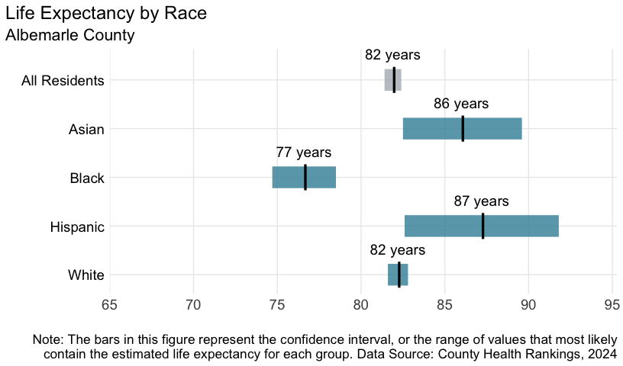

Figure 3.1: Life Expectancy by Race, 2024. Average life expectancies with confidence intervals for all county residents (82 yrs), Asian residents (86 yrs), Black residents (77 yrs), Hispanic residents (87 yrs), and white residents (82 yrs).

Black residents in Albemarle have a lower life expectancy at birth (77 years) compared to white residents (82 years)—a difference of five years. While the life expectancy for Hispanic and Asian community members appears to be quite high, the much smaller populations on which these estimates are based mean there is less certainty about these values. Thus, Figure 3.1 provides not just the life expectancies, but the range of possible values suggested by the available data.

Geographically, life expectancy varies across the county.

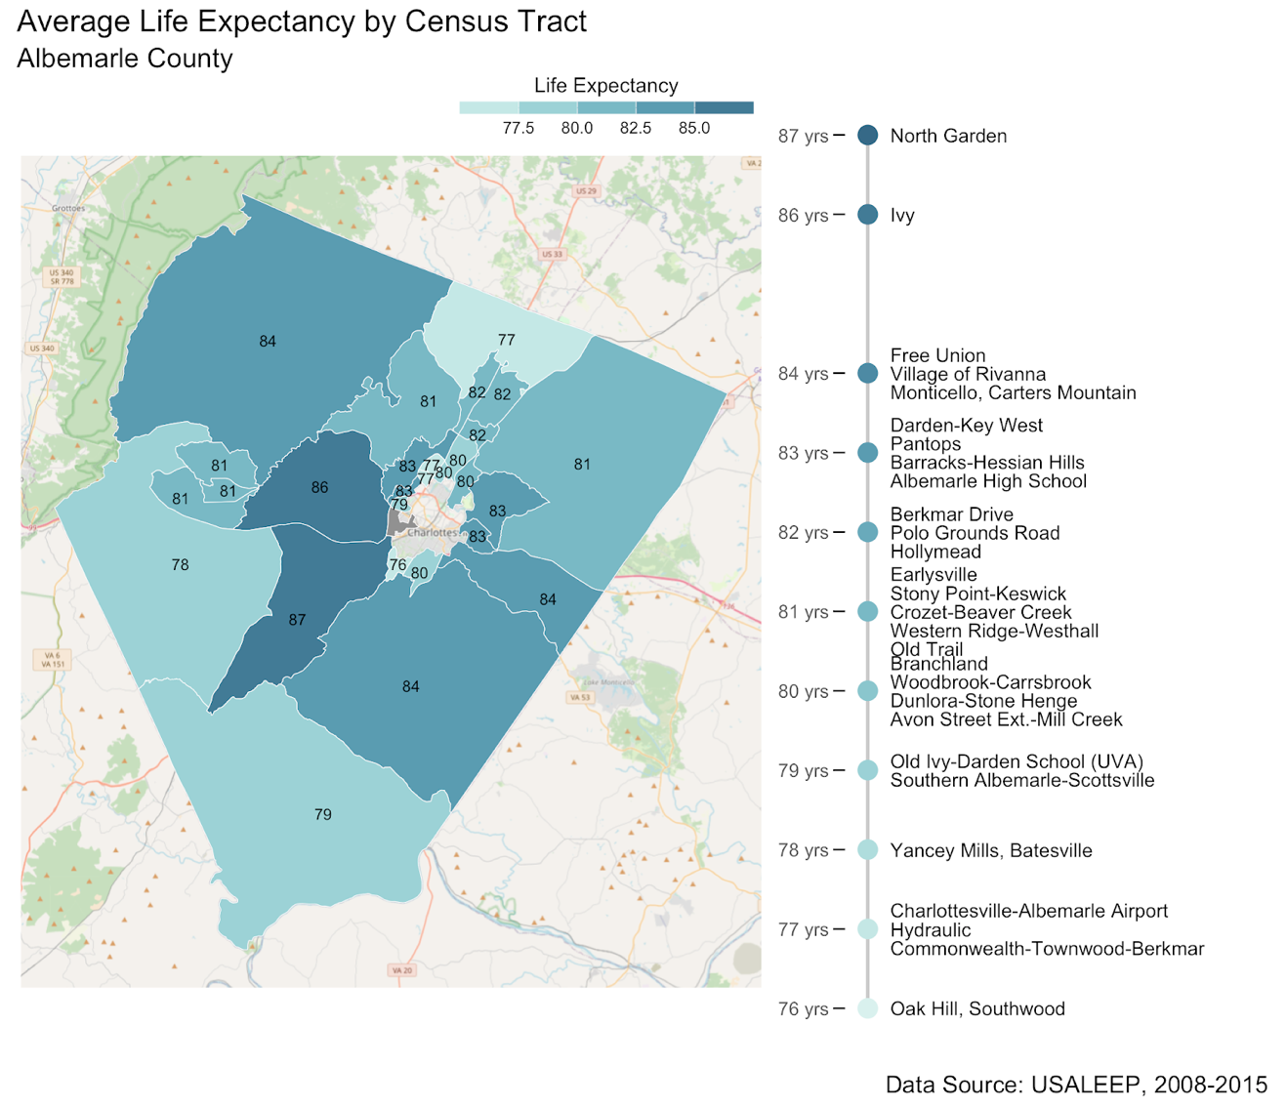

Figure 3.2: Average Life Expectancy by Census Tract. Average life expectancy in Albemarle ranges by tract, from 76 years in the Oak Hill/Southwood area to 87 years in North Garden.

The maximum difference is 11 years across neighborhoods: North Garden enjoys the longest life expectancy (87 years) and the Oak Hill/Southwood area experiences the shortest (76 years).

### Food Security

Consistent access to sufficient and nutritious food is vital to well-being. A community cannot reach its full potential if some of its members are going hungry or cannot access affordable and healthful food. Looking at the national statistics, hunger and food insecurity are experienced unequally: overall, low-income communities and people of color are more likely to experience food insecurity; further, children and seniors are more vulnerable to the health and developmental setbacks that come with insufficient or nutrient-deficient food.[43]

Albemarle has an overall rate of food insecurity of 10%. The rate is lower among children, with 8% of children experiencing food insecurity. Racial and ethnic groups in the county also experience food insecurity differently: 22% of Black individuals and 16% of Hispanic individuals are food insecure, compared to 7% of white individuals.

|  |  |
| --- | --- |
| **Overall Food Insecurity**  1 in 10  people experience  food insecurity (10%) | **Food Insecurity Rate Among Black Residents**  2 in 10  Black individuals  experience food insecurity (22%) |
| **Food Insecurity Rate Among Hispanic Residents**  2 in 10  Hispanic individuals  experience food insecurity (16%) | **Food Insecurity Rate Among White Residents**  1 in 10  white individuals  experience food insecurity (7%) |
| **Child Food Insecurity Rate**  1 in 10  children experience  food insecurity (8%)  Figure 3.3: Food Insecurity Rates in Albemarle County, 2022. | |

Figure 3.3: Food Insecurity Rates in Albemarle County, 2022.

### Health Outcomes & Prevention

Estimates of local health outcomes and prevention activities can point to places and problems where interventions are most needed. The following two tables show health measures at the census tract level.

Table 4 displays the probability of adult residents reporting the listed health conditions: asthma, high blood pressure, cancer, diabetes, depression, high cholesterol, and obesity. A higher percentage corresponds with a higher likelihood of adults in that census tract having the medical condition.

In most areas of Albemarle, around 30-40% of adults are likely to have high blood pressure and high cholesterol. The percentage of adults with asthma in the county ranges from 8-11%.

**Table 4:** **Health Outcomes by Census Tract***1*

|  | ASTHMA | HIGH BLOOD PRESSURE | CANCER | DIABETES | DEPRESSION | HIGH CHOLESTEROL | OBESITY |
| --- | --- | --- | --- | --- | --- | --- | --- |
| Albemarle High School | 11% | 32% | 8% | 13% | 26% | 35% | 35% |
| Avon Street Ext.-Mill Creek | 10% | 28% | 7% | 9% | 25% | 33% | 32% |
| Barracks-Hessian Hills | 10% | 31% | 10% | 11% | 23% | 34% | 30% |
| Berkmar Drive | 10% | 31% | 8% | 12% | 24% | 35% | 33% |
| Branchland | 10% | 35% | 12% | 12% | 22% | 37% | 29% |
| Carr's Hill-McCormick Road (UVA) | 10% | 11% | 1% | 3% | 26% | 16% | 22% |
| Charlottesville-Albemarle Airport | 10% | 32% | 10% | 11% | 24% | 37% | 32% |
| Commonwealth-Townwood-Berkmar | 10% | 32% | 8% | 12% | 24% | 35% | 34% |
| Crozet-Beaver Creek | 10% | 33% | 10% | 10% | 24% | 38% | 30% |
| Darden-Key West | 9% | 32% | 11% | 11% | 23% | 39% | 29% |
| Dunlora-Stone Henge | 10% | 32% | 10% | 11% | 25% | 37% | 32% |
| Earlysville | 9% | 36% | 13% | 12% | 23% | 42% | 30% |
| Free Union | 10% | 37% | 12% | 12% | 25% | 41% | 32% |
| Hollymead | 9% | 30% | 9% | 10% | 23% | 36% | 30% |
| Hydraulic | 10% | 31% | 7% | 10% | 23% | 32% | 33% |
| Ivy | 9% | 34% | 12% | 11% | 22% | 41% | 29% |
| Monticello, Carters Mountain | 10% | 33% | 10% | 11% | 24% | 38% | 32% |
| North Garden | 9% | 33% | 11% | 11% | 23% | 39% | 30% |
| Oak Hill, Southwood | 10% | 22% | 4% | 7% | 27% | 25% | 33% |
| Old Ivy-Darden School (UVA) | 8% | 19% | 5% | 5% | 24% | 23% | 24% |
| Old Trail | 9% | 33% | 12% | 11% | 23% | 39% | 30% |
| Pantops | 9% | 34% | 12% | 12% | 22% | 37% | 28% |
| Polo Grounds Road | 9% | 30% | 9% | 10% | 22% | 37% | 28% |
| Southern Albemarle-Scottsville | 10% | 38% | 10% | 13% | 25% | 40% | 35% |
| Stony Point-Keswick | 10% | 38% | 12% | 13% | 23% | 41% | 32% |
| Village of Rivanna | 9% | 37% | 13% | 13% | 22% | 42% | 30% |
| Western Ridge-Westhall | 9% | 30% | 9% | 10% | 25% | 36% | 31% |
| Woodbrook-Carrsbrook | 10% | 34% | 10% | 12% | 23% | 38% | 31% |
| Yancey Mills, Batesville | 10% | 36% | 11% | 13% | 25% | 40% | 34% |
| *1*Health outcome measure definitions available here: https://www.cdc.gov/places/measure-definitions/health-outcomes/index.html | | | | | | | |
| Data Source: Centers for Disease Control and Prevention, National Center for Chronic Disease Prevention and Health Promotion, Division of Population Health, 2024 | | | | | | | |

Table 5 shows the probability that adult residents engaged in routine health visits by census tract. This includes an annual health checkup or annual dental visit over the past year, and a screening for breast cancer or colorectal cancer at the recommended age and yearly interval. Here, a higher percentage means a higher chance an adult in each census tract had a routine health visit.

Lower percentages suggest less access to routine health care. While annual check-ups and breast cancer screenings are relatively high across all tracts, residents in some areas appear more likely to skip routine appointments for colorectal cancer screenings and dental health.

**Table 5:** **Health Prevention Measures by Census Tract***1*

|  | ROUTINE CHECKUP | DENTAL VISIT | MAMMOGRAPHY USE | COLORECTAL CANCER SCREENING |
| --- | --- | --- | --- | --- |
| Albemarle High School | 78% | 63% | 79% | 65% |
| Avon Street Ext.-Mill Creek | 77% | 71% | 81% | 72% |
| Barracks-Hessian Hills | 80% | 70% | 81% | 74% |
| Berkmar Drive | 79% | 67% | 79% | 64% |
| Branchland | 82% | 69% | 80% | 72% |
| Carr's Hill-McCormick Road (UVA) | 72% | 58% | 75% | 61% |
| Charlottesville-Albemarle Airport | 81% | 75% | 82% | 74% |
| Commonwealth-Townwood-Berkmar | 79% | 67% | 82% | 70% |
| Crozet-Beaver Creek | 81% | 76% | 81% | 71% |
| Darden-Key West | 81% | 77% | 80% | 76% |
| Dunlora-Stone Henge | 81% | 73% | 80% | 74% |
| Earlysville | 83% | 78% | 81% | 77% |
| Free Union | 81% | 72% | 81% | 75% |
| Hollymead | 80% | 76% | 83% | 71% |
| Hydraulic | 79% | 71% | 81% | 72% |
| Ivy | 83% | 79% | 83% | 76% |
| Monticello, Carters Mountain | 80% | 74% | 80% | 74% |
| North Garden | 82% | 76% | 81% | 73% |
| Oak Hill, Southwood | 74% | 62% | 76% | 64% |
| Old Ivy-Darden School (UVA) | 74% | 66% | 79% | 74% |
| Old Trail | 82% | 78% | 79% | 73% |
| Pantops | 82% | 74% | 84% | 77% |
| Polo Grounds Road | 80% | 78% | 81% | 69% |
| Southern Albemarle-Scottsville | 81% | 69% | 79% | 73% |
| Stony Point-Keswick | 82% | 74% | 81% | 75% |
| Village of Rivanna | 83% | 77% | 82% | 78% |
| Western Ridge-Westhall | 79% | 75% | 81% | 69% |
| Woodbrook-Carrsbrook | 81% | 74% | 79% | 76% |
| Yancey Mills, Batesville | 81% | 71% | 80% | 72% |
| *1*Health prevention measure definitions available here: https://www.cdc.gov/places/measure-definitions/prevention/index.html | | | | |
| Data Source: Centers for Disease Control and Prevention, National Center for Chronic Disease Prevention and Health Promotion, Division of Population Health, 2024 | | | | |

### Health Insurance

Health insurance supports access to routine health care and provides some protection from unanticipated medical expenses. In Albemarle, 1 in 20 people do not have health insurance (Figure 3.4). Those without insurance are less likely to have a primary care provider, are more likely to delay or forgo needed care, and receive fewer preventative services.[44]

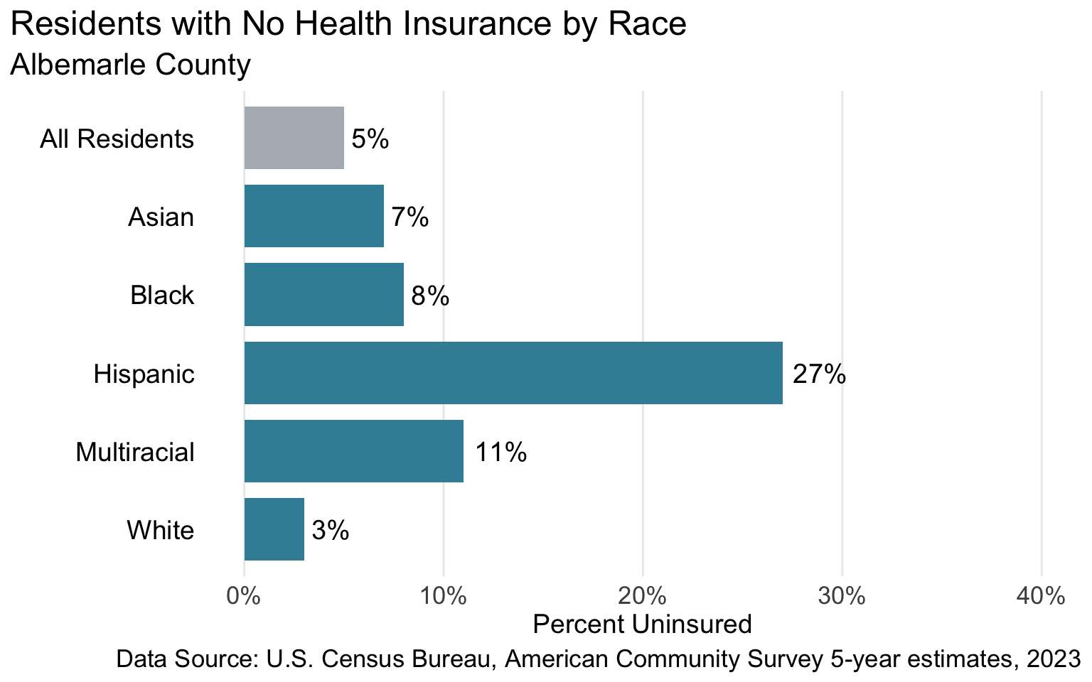

Figure 3.4: Residents with No Health Insurance by Race, 2023. Overall, approximately 5% of residents do not have health insurance. This value is 7% for Asian residents, 8% for Black residents, 27% for Hispanic residents, 11% for multiracial and 3% white.

Significant disparities exist across racial and ethnic groups in Albemarle: 27% of Hispanic residents report that they do not have health insurance compared to 3% of white residents. Put differently, nearly 3 in 10 Hispanic residents in the county do not have health insurance.

Differences in health insurance coverage can also be seen geographically in Albemarle (Figure 3.5).

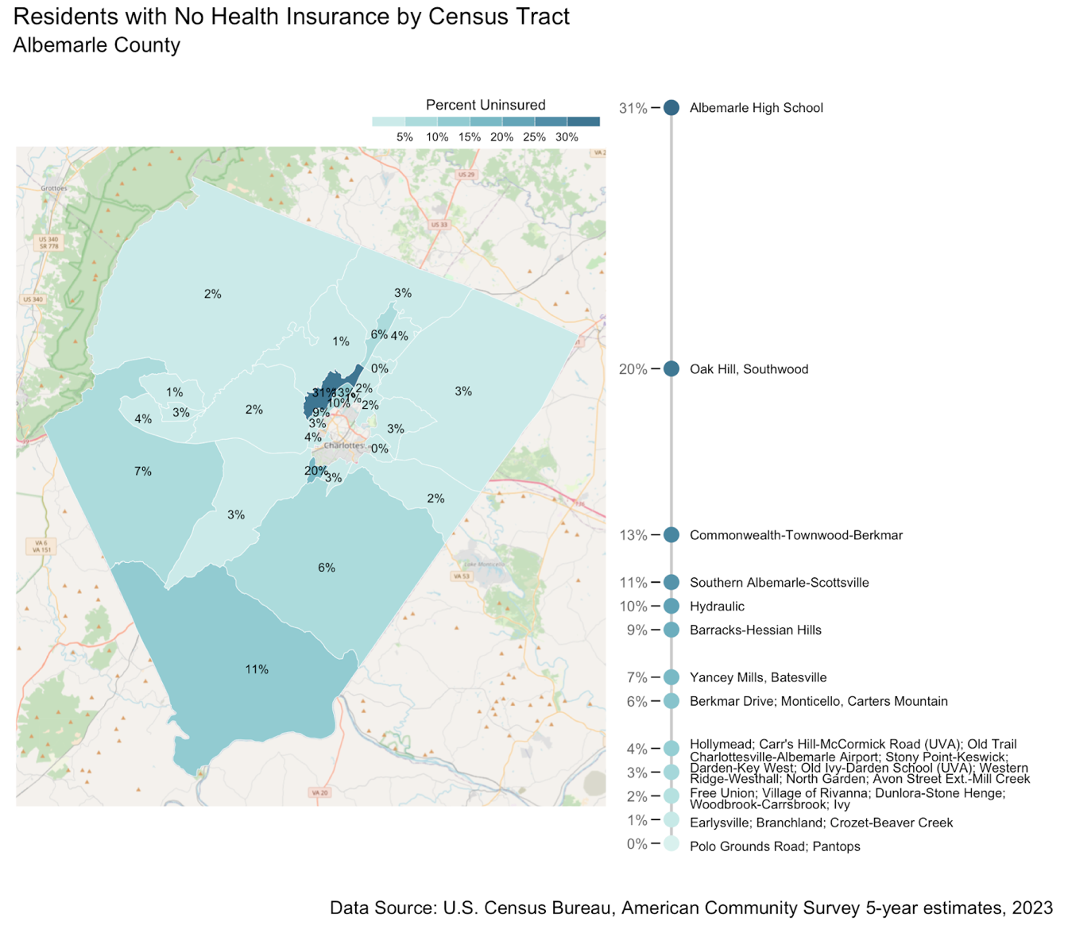

Figure 3.5: Residents with No Health Insurance by Census Tract. The percent of residents without health insurance ranges from lows between 0%-4% in many tracts to a high of 31% in the Albemarle HS area.

The percent of residents without health insurance ranges from a low of 0% to a high of 31%. While the rate of no health insurance is under 10% for most areas of the county, there are five tracts with higher rates: Hydraulic (10%), Southern Albemarle-Scottsville (11%), Commonwealth-Townwood-Berkmar (13%), Oak Hill, Southwood (20%), and Albemarle High School (31%). Strategies to increase insurance coverage rates are critical for making sure more people get important health care services, like preventive care and treatment for chronic illnesses.

### EMS Responses to Opioid Overdoses

Substance Use Disorder (SUD) is a public health issue that impacts our whole community. Harm reduction programs and policy can directly help those suffering from SUD. One of the ways we can monitor the severity of substance use in the community is through the number of calls to Emergency Medical Services (EMS) related to opioid overdoses.

There is some geographic concentration in EMS calls for opioid overdose over the five-year period of 2019-2023. There were more calls received in the more developed areas around the City of Charlottesville and in Southern Albemarle (Figure 3.6).

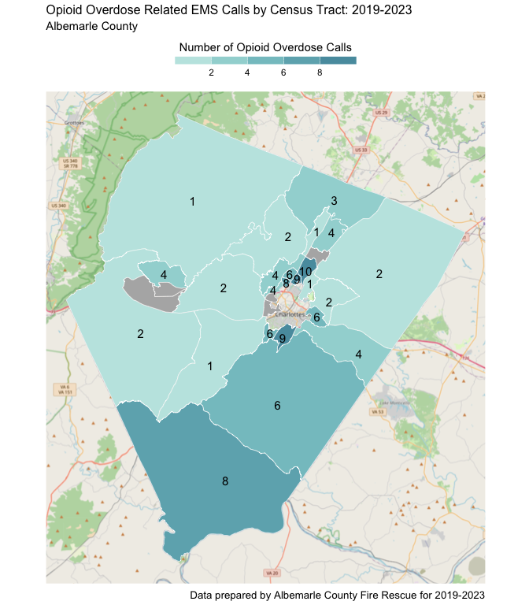

Figure 3.6: EMS Responses to Opioid Overdoses by Census Tract: 12/1/16-7/10/24. The number of emergency services responses to overdoses varies by place, with higher numbers in the south/eastern region of the county and in tracts bordering the City of Charlottesville.

### Policy Connections

Improved health, for individuals and the community, depends on access to quality health care and health-supporting environments. Health equity is enhanced when all residents share in this access.

The complexity of health coverage options can pose a burden for individuals without health insurance.[45] Increasing outreach and enrollment support has proven to increase uptake of health insurance.[46],[47] Because many residents will remain uninsured or under-insured, investment in alternative medical care, like that offered by the Free Clinic, will remain an important resource for the community. Even with health insurance coverage, accessing care frequently poses an additional hurdle. Programs that bring health care providers to residents—embedding clinics and nurse practitioners in communities of need, mobile clinics and services, in-school health checks—increase use of preventative services and care for chronic conditions. Community health workers can further amplify outreach, education, health navigation, and ultimately, use of health resources in targeted communities.[48] Residents, especially low-income residents, may remain wary of accessing health resources if they fear accruing medical debt and the consequences of aggressive debt collection practices by health-providing systems.

Healthy environments afford access to healthful foods, green spaces and safe walkability, and protection from harmful pollutants, heat, and related conditions of the built environment. Proximity to healthy food retailers and sources promotes healthier diets and lowers the risk of food insecurity.[49] Subsidizing the development of grocery stores and community gardens in more urban communities advances the health of communities. Nearby parks, trails, and open spaces that promote physical activity can improve the physical and mental health of residents, especially among urban and suburban residents.[50] In addition to supporting physical activity, green spaces and green infrastructure play a role in reducing environmental hazards like heat in urban areas.

The rise of fatal opioid overdoses in the Commonwealth, driven largely by the rise in synthetic opioids, are also reflected locally. Research supports harm reduction as a key strategy: naloxone distribution and education as well as syringe service programs and fentanyl test strip distribution.[51] The work of the Community Mental Health and Wellness Coalition in sharing and amplifying access to harm reduction training and resources is more necessary than ever.[52] While Virginia passed a safe reporting law in 2015,[53] continued efforts to raise awareness of the protections from arrest and prosecution afforded by the law could reduce barriers to receiving lifesaving care.

## Access to Knowledge: Education Profile

Education promotes personal development in multiple ways and directly influences employment and earnings, which in turn influence access to decent housing, food, healthcare, transportation, and more. Education also enhances individual and collective civic life. Albemarle County is notable for its well-educated population, further supported by hosting a high-ranking university. More granular data on educational attainment in Albemarle County tells a more complex story and points to paths for improvement.

### Degree Attainment

Differences in educational attainment by race and ethnicity for those aged 25 years or older raise stark equity concerns (Figure 4.1); 65% of white adults hold a bachelor’s degree or higher compared to 31% of Black adults and 36% of Hispanic adults. Additionally, 1 out of 5 Hispanic residents in the County have less than a high school diploma—the highest percent of any racial/ethnic group present in this data.

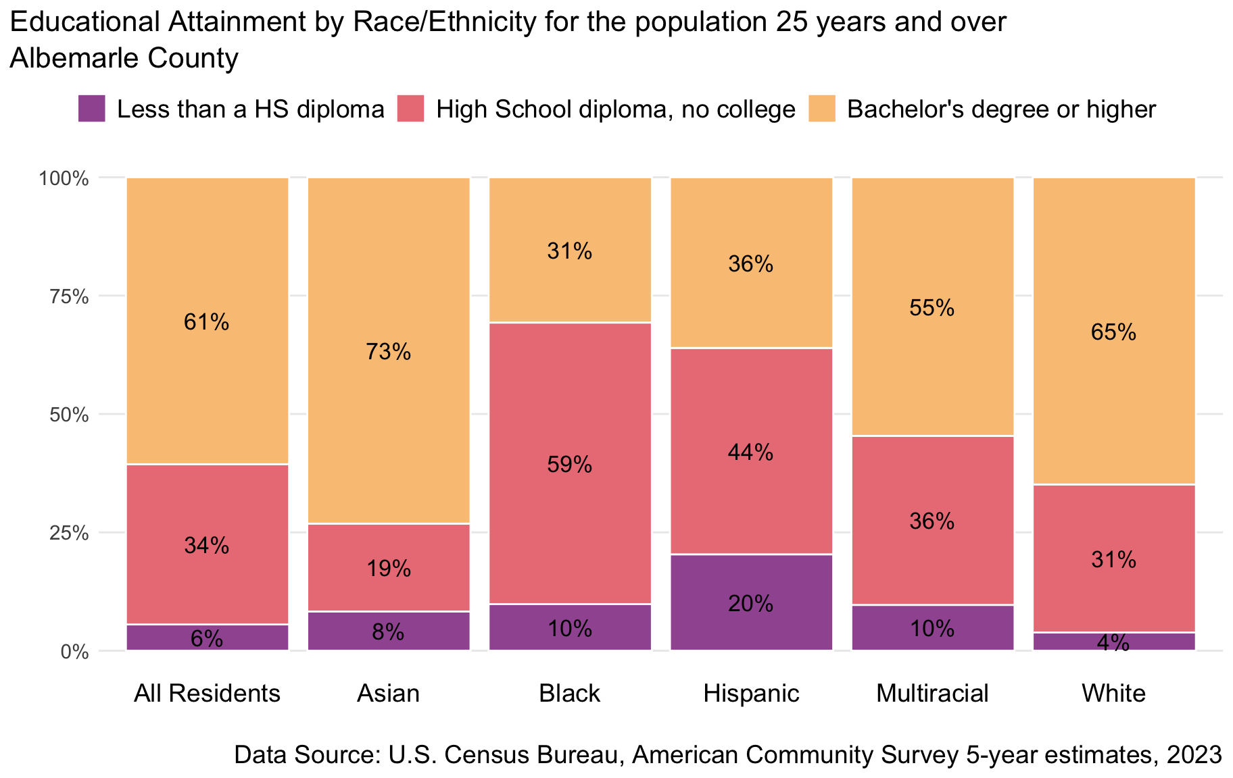

Figure 4.1: Educational Attainment by Race/Ethnicity for the population 25 years and over, 2023. While 61% of residents overall have a bachelor’s degree or higher, 31% of Black residents, 36% of Hispanic residents, and 65% of white residents have BA’s or higher.

There is also significant geographic variation in the rates of bachelor’s degree attainment throughout Albemarle County (Figure 4.2). In nearly one third of the tracts in the county, over 70% of residents have a rate of bachelor’s degree. However, there are also seven tracts where less than half of residents 25 years and older have a bachelor’s degree. These areas include Southern Albemarle/Scottsville and Commonwealth-Townwood-Berkmar with rates of degree attainment of 40% and 37% respectively.

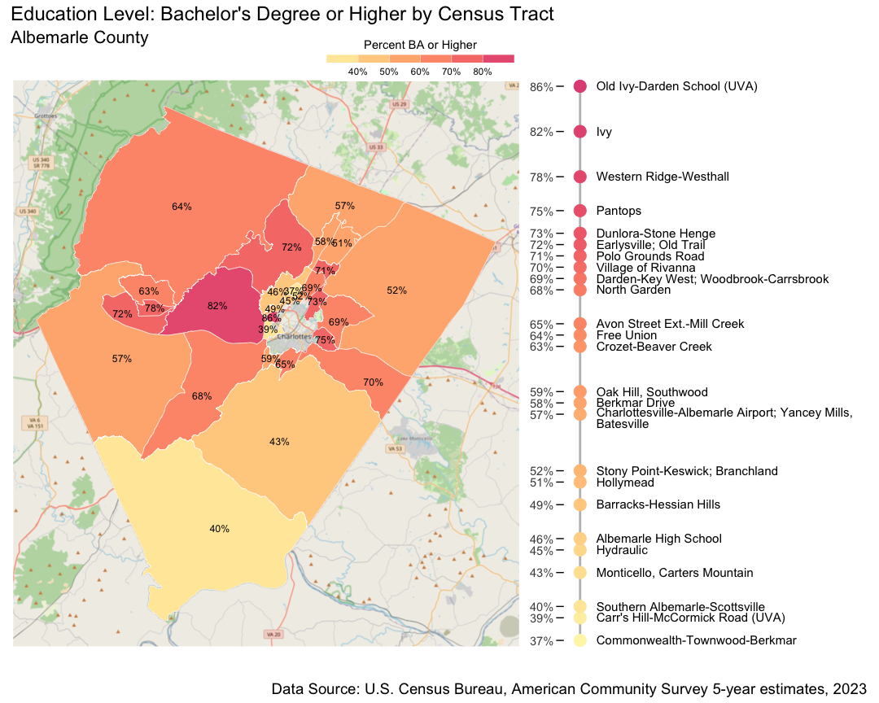

Figure 4.2: Education Level: Bachelor’s Degree or Higher by Census Tract for the population 25 years and older, 2023. Bachelor’s degree attainment ranges from 37% in the Commonwealth-Townwood-Berkmar tract to 86% in the Old Ivy-Darden School area.

There are many post-secondary alternatives to attaining a bachelor’s degree that can prepare students for successful careers not accounted for in these data, including associate's degrees, vocational certificate programs, and apprenticeships. Even so, greater levels of higher education in an area are associated with positive social outcomes for the entire community, including lower crime rates, greater civic engagement, and longer and healthier lives.[54] The geographic clustering by education means these additional benefits of education are also distributed unequally.

### School Enrollment

School enrollment measures how many young people, ages 3 to 24 years, currently attend a public school, private school, college or university.[55] Like degree attainment, there are geographic disparities in the rate of school enrollment across Albemarle. Overall, the school enrollment rates for ages 3-24 are high in Albemarle County, between 70-98% for most tracts. Three tracts fall below these rates: in Oak Hill/Southwood school enrollment is 68%, Branchland is 56%, and in the Hydraulic area the rate is 53%.

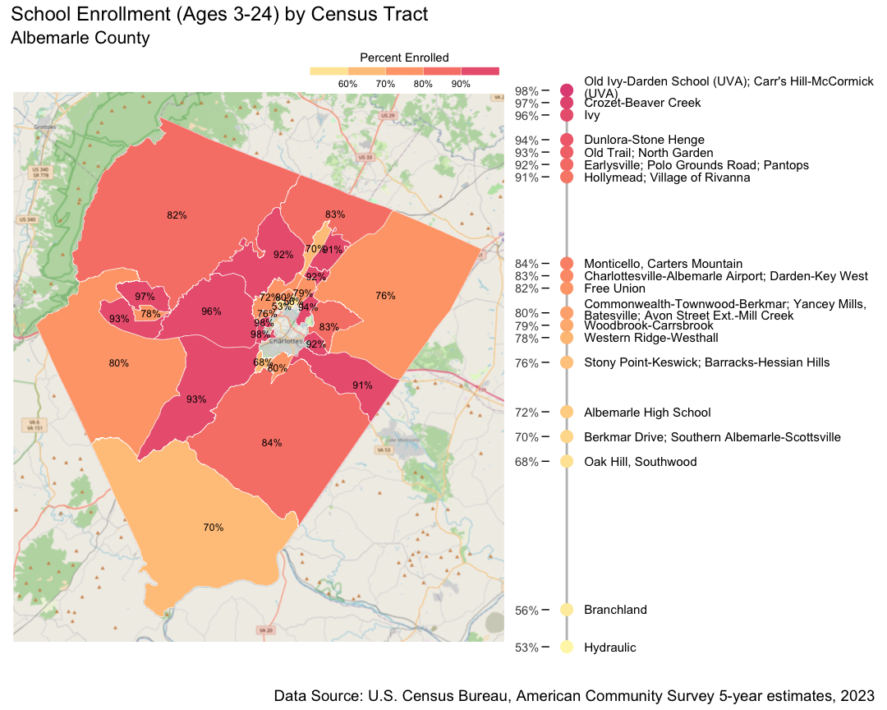

Figure 4.3: School Enrollment (Ages 3-24) by Census Tract, 2023. School enrollment ranges from 53% in Hydraulic to 98% in the Carr’s Hill-McCormick Road (UVA) and Old Ivy-Darden School (UVA) tracts.

Apart from the rate of formal school attendance among young people, data from the Albemarle County Public School (ACPS) District point to disparities in the experience of school among youth on the basis of race and ethnicity.

### AP & Dual Enrollment

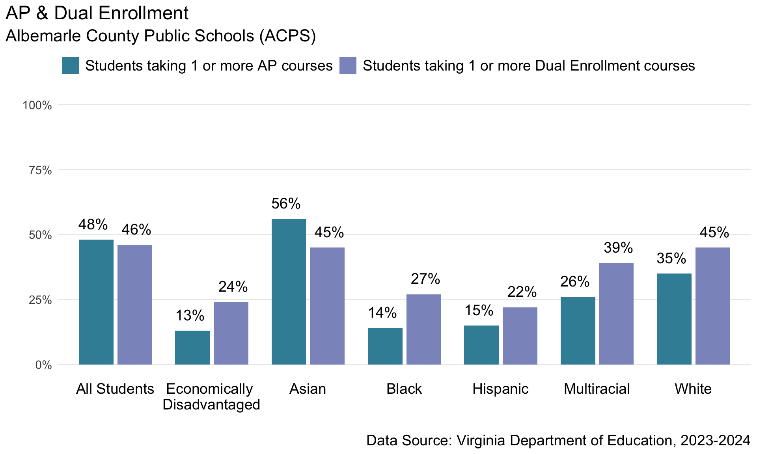

Figure 4.4: AP & Dual Enrollment in ACPS, 2023-2024. For all students, 10th-12th grades, 48% are taking 1 or more AP courses. For students 11th-12th grades, 46% are enrolled in 1 or more Dual Enrollment courses.

Data on advanced placement (AP) and dual enrollment courses among ACPS students in the 2023-2024 school year shows higher rates of enrollment in both programs among white, multiracial, and Asian students, relative to all other groups. 35% of white students were taking 1 or more AP courses compared to 14% of Black students and 15% of Hispanic students. The differences were less pronounced for dual enrollment classes, but white students were still nearly twice as likely to be in dual enrollment classes relative to Black and Hispanic students.

### Suspensions

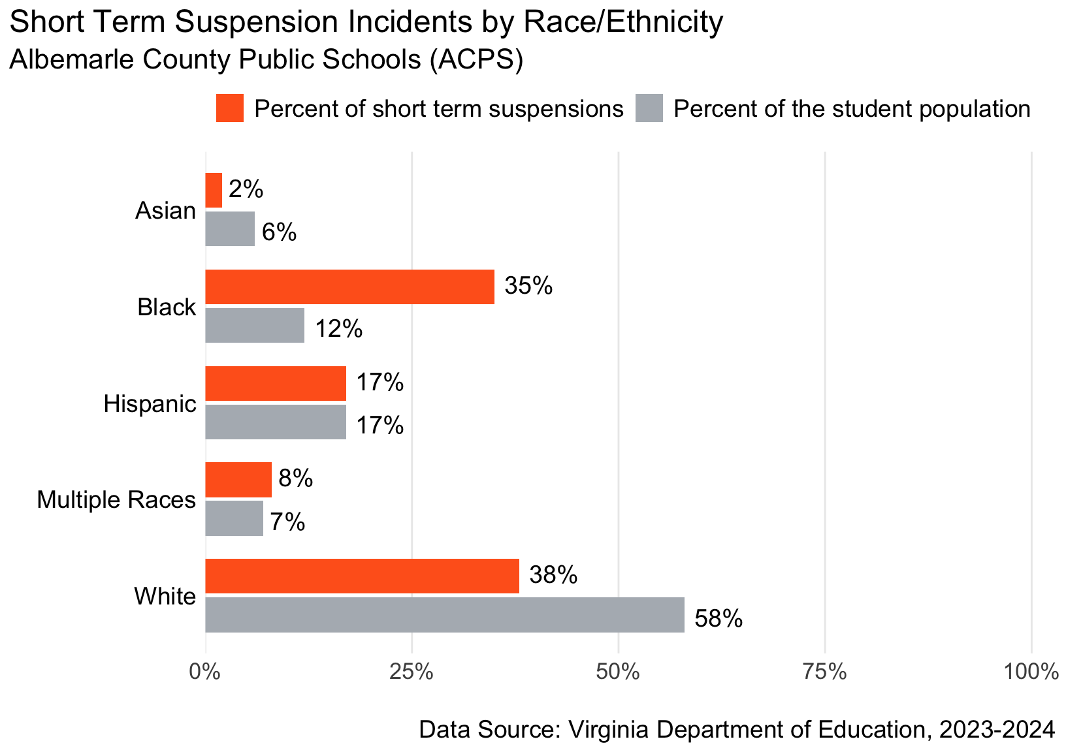

Figure 4.5: Short Term Suspension Incidents by Race/Ethnicity in ACPS, 2023-2024. While 38% of short-term suspensions are given to white students and 35% to Black students, white students account for 58% of the student body and Black students account for 12%.

Albemarle County Public Schools saw significant racial disparities among students receiving short term suspensions in the 2023-2024 school year. Though Black students constituted just 12% of the ACPS student population, Black students received suspensions in 35% of all short term suspension incidents. Research suggests that at least some of this disparity results from racial bias in disciplinary outcomes for students exhibiting the same behavior in U.S. schools.[56]

### Chronic Absenteeism

In the years following the initial onset of the COVID-19 pandemic, rates of chronic absenteeism in schools throughout the U.S. have skyrocketed: national-level data shows that rates of chronic absenteeism in U.S. schools increased from 15% in 2019 to 26% in 2023.[57] In Virginia, students are considered chronically absent when they miss 10% or more of the school year, which includes unexcused and excused absences, and suspensions.[58] Overall chronic absenteeism in Albemarle County Public Schools during the 2023-2024 school year were lower than national trends, with 13% of ACPS students considered chronically absent.

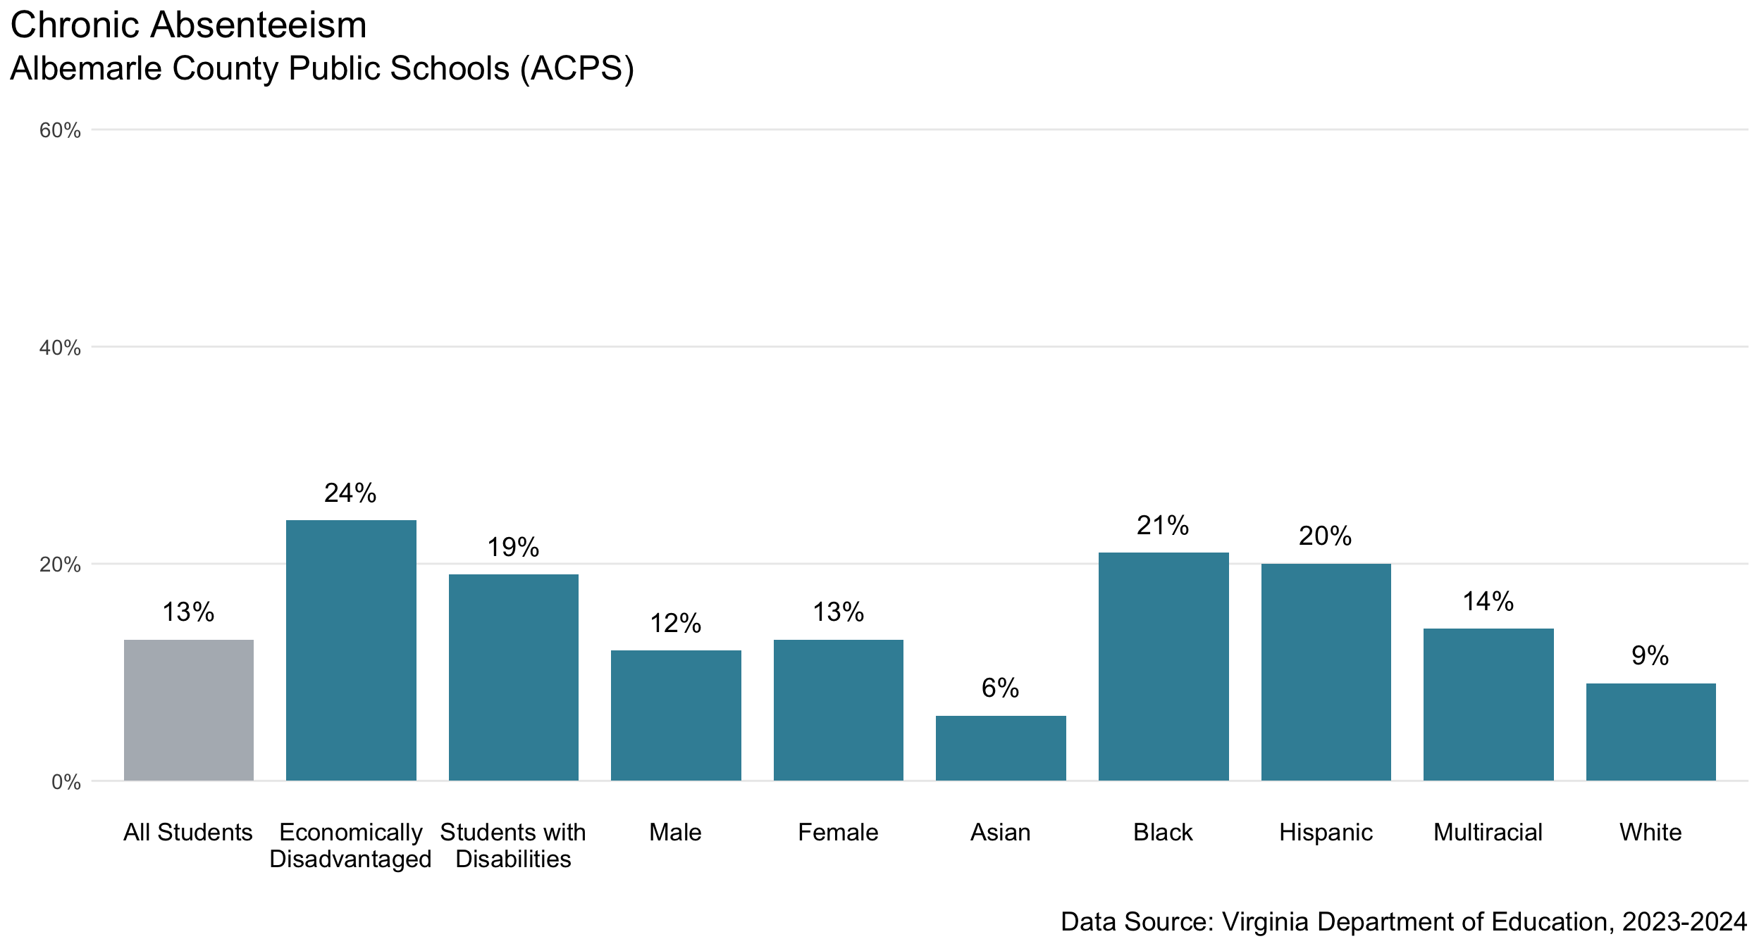

Figure 4.6: Chronic Absenteeism in ACPS, 2023-2024. The rate of chronic absenteeism for all students is 13%. This is higher for Black and Hispanic students, as well as economically disadvantaged students and students with disabilities.

The demographic differences in chronic absenteeism rates, however, are troubling. Economically disadvantaged students and students with disabilities had notably higher rates of chronic absenteeism, at 24% and 19% respectively. The rate of chronic absenteeism for Black students was 21% and for Hispanic students it was 20%. By contrast, 15% of white students were considered chronically absent.

### Policy Connections

Access to quality education, a central component of the social determinants of health, has been repeatedly shown to be key to economic security, civic engagement, and better health outcomes.[59]

Early childhood development and education programs, childcare and pre-kindergarten, prepare children for kindergarten and beyond, helping to reduce educational gaps.[60] There are currently too few affordable early childhood programs in the area, with thousands of additional childcare slots needed.[61] These needs cannot be met without support for training and compensation for early childhood educators.

Once in school, students need supportive environments to thrive. This includes reducing the racial disproportionality in disciplinary outcomes, a well-documented phenomenon across the country.[62] Building a culturally sustaining school climate that fosters students’ socio-emotional learning may reduce these disparities.[63] Experts also suggest paying attention to disciplinary referrals, and the initial acts that might lead to suspension, to better understand the referred behavior at the onset.[64] Attention to expanding access to accelerated classes can promote more equitable school environments. Strategies include “automatic enrollment” policies to identify all high schoolers who meet preparedness criteria[65] as well as making state[66] and school-level programs to cover the cost of advanced courses highly visible and simple to access.[67]

Higher-education degree attainment is strongly predictive of economic security and longevity.[68] Reducing structural barriers to accessing higher education is necessary to reduce disparities in post-secondary educational attainment. The State Council on Higher Education for Virginia (SCHEV) created a statewide plan in 2021 intended to help close racial and economic post-secondary education gaps including by increasing awareness of higher education opportunities to those who might perceive them to be out of reach; investing in supportive services for students like counseling, mentoring, and career services; and reducing the cost of post-secondary education.[69] At the local level, investing in focused pathways programs for middle and high school students can help to address systemic obstacles to college-going.

## Decent Standard of Living: Economic Security and Housing Profile

Living standards encompass access to the material needs of life—housing, security, goods and services. It is captured through measures on earnings, household income, homeownership and renting. Data on earnings and income contextualize the struggle some residents face to achieve economic stability and to afford basic necessities. Data on home ownership and housing burden point to the pressing challenges around housing affordability. Collectively, these measures reveal some of the county’s most glaring inequities, both racially and geographically.

### Earnings and Income

The median personal earnings of Albemarle residents vary significantly by sex and by race (Figure 5.1). Median earnings represent the midpoint of all household incomes, meaning half of households earn more and half earn less than that amount. The median is generally considered a more representative measure of typical income compared to the average, as it's not affected by extreme outliers (very high or low incomes).

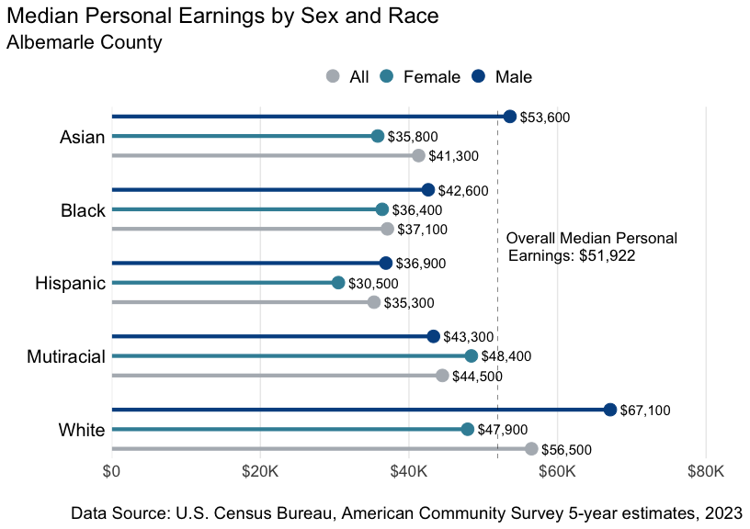

Figure 5.1: Median Personal Earnings by Sex and Race, 2023. The overall median personal earnings is $51,922. White and Asian men earn more, at $67,100 and $53,600 respectively. All others earn less, with the least earned on average being Hispanic women at $30,500.

There are wide disparities in personal earnings between white residents, whose median personal earnings are $56,500 a year, and other racial and ethnic groups. Black residents earn $37,100 and Hispanic residents earn less, around $35,300 a year. The median for Black, Hispanic and Multiracial residents, both men and women, is less than Albemarle’s overall median personal earnings ($51,922). For white residents, there is a clear gender gap in earnings, with white women earning 28% less than their male counterparts. There is also a notable gap in earnings between Asian men and women, with Asian women earning more than 33% less. These data raise serious concerns about the differential barriers to economic mobility and wealth-building for Albemarle residents.

While median personal earnings quantify well-being at the individual level, economic power is often pooled within family units. And many tax and policy interventions are monitored at the household level. Here, we focus on median household income to more directly relate financial well-being to the cost of living in the area.

The median household income for Albemarle is high, around $102,600 a year—the value for which half of households bring in more and half bring in less. Examining differences in median household income across census tracts adds further context to economic inequality in Albemarle.

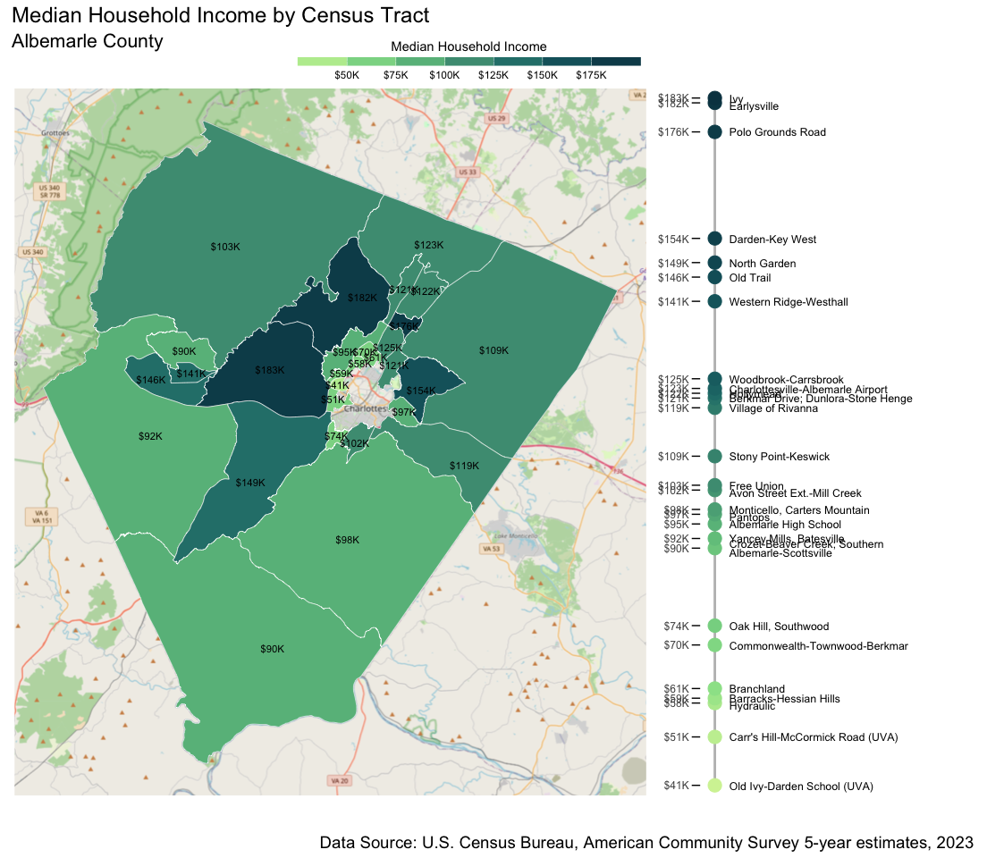

Figure 5.2: Median Household Income by Census Tract, 2023. Annual household income ranges from $41,000 to $183,000 in Albemarle County.

Median household income by census tract ranges from a low of $41,000, to a high of $183,000. The tracts with the lowest median household incomes are near the University: Carr’s Hill-McCormick Road (UVA) and Old-Ivy-Darden School (UVA). The presence of University student housing can impact economic measures, however, students do not account for the whole of the households in these neighborhoods, which can also be impacted by structural poverty. Areas like Hydraulic, Barracks-Hessian Hills, and Branchland have lower student populations, yet have markedly lower household incomes than the county’s most affluent census tracts. While Hydraulic and Branchland have median household incomes of $58,000 and $61,000 respectively, households in Earlysville and Ivy make well over three times that much, over $180,000 a year.

As with personal earnings, data on median household income by race reveal troubling racial and ethnic disparities.

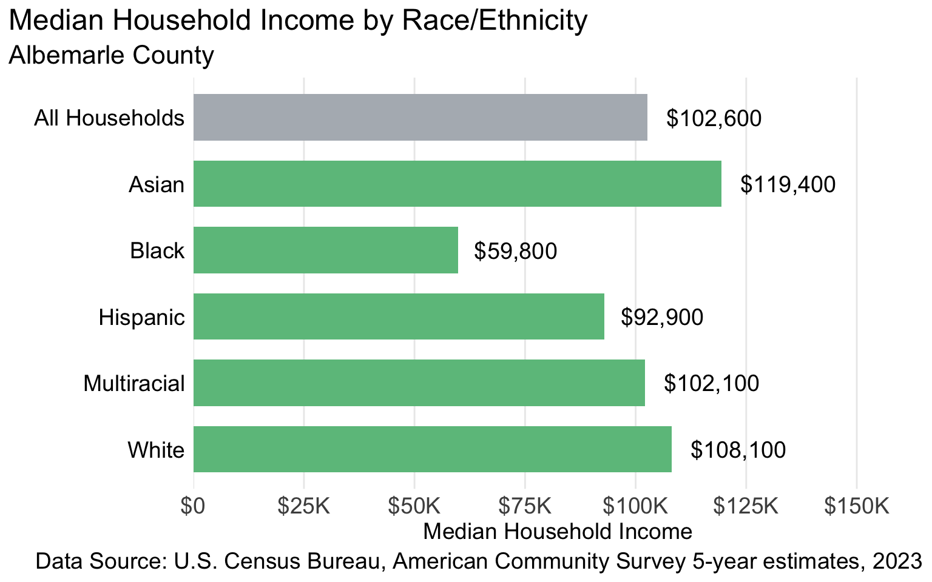

Figure 5.3: Median Household Income by Race/Ethnicity, 2023. Median annual income for all households in Albemarle County is $102,600. For white households, this income is $108,000/year, and $59,000/year for Black households.

At the national level, Black workers are underrepresented in industries with the highest wages, with 45% of Black workers in the private-sector working in retail, healthcare, accommodation and food service—jobs that often involve part-time schedules and relatively low wages.[70] This stratification is reflected locally as well, with Black households receiving a median income of $59,800, while the median income for white households was nearly double this amount, at $108,100. Low household income can mean that a family is unable to afford basic necessities: according to the Orange Dot Report 6.0, 46% of Black families and 30% of Hispanic families in Albemarle County do not earn enough to be self-sufficient, compared to 15% of white families.[71]

### Struggling Families: Asset Limited, Income Constrained, Employed (ALICE)

Comprehensive measures of financial hardship must consider both income and the broader cost of living: United Way developed the asset limited, income constrained, employed (ALICE) threshold for this purpose.[72] The ALICE threshold is calibrated to specific localities, and represents the lowest possible income that households need to earn to afford their basic needs. These essentials include the costs of housing, healthcare, food, transportation, technology, taxes, and childcare.

Many households with incomes below their local cost of living threshold, but above the federal poverty line may not be traditionally thought of as financially burdened. Because their incomes are above the federal poverty line, these households do not qualify

for some federal assistance programs[73] and their disadvantaged financial status is often overlooked by local governments. Inequities are amplified when local government interventions neglect the burdens of households who are working hard, and earning above the federal poverty threshold, but still not enough to meet their family’s basic needs.

Figure 5.4 below shows how the ALICE threshold, or the real cost of living, for Albemarle County has increased over the past decade. In 2010, this threshold for survival was $50,000 for households under 65; this grew to $78,000 in 2022.

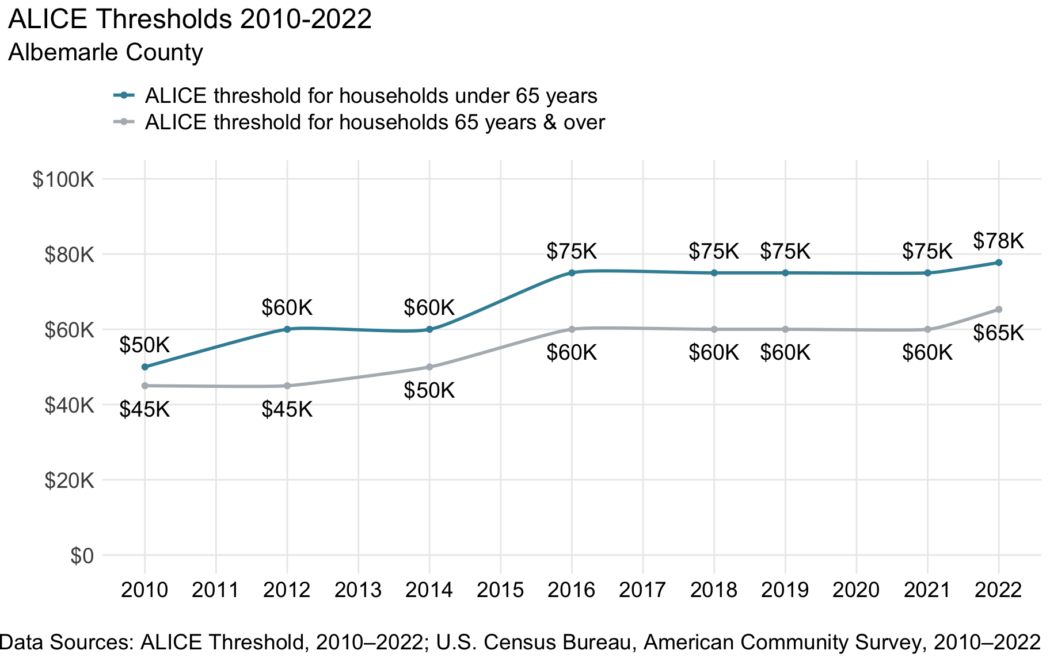

Figure 5.4: ALICE Thresholds 2010-2022. The ALICE threshold for households under 65 years old was $78,000 in 2022 and $68,000 for 65 years and older.

The percentages of households with incomes below the poverty line and under the ALICE threshold differs across race and ethnicity (Figure 5.5):

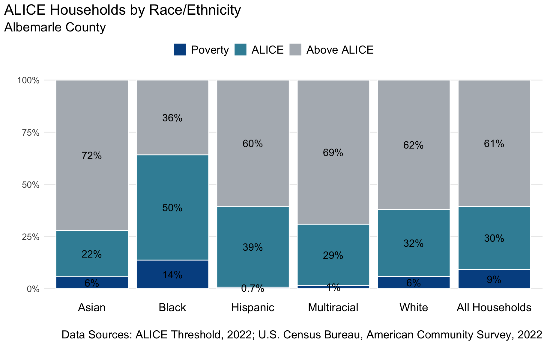

Figure 5.5: ALICE Households by Race/Ethnicity, 2022.

Overall, 9% of households in Albemarle are earning incomes below the federal poverty line and 30% of families earn above this amount but below the ALICE threshold, meaning they struggle to afford their basic needs. For Black and Hispanic households, the percent earning below the ALICE threshold is even higher—at 50% and 39%, respectively.

### Housing: Renters and Owners

Housing costs are one of the primary drivers of the rising costs of living. Housing is a significant expense, and in our housing affordability crisis there can be limited options for those families who are not earning enough to meet the area’s rising costs.

Zillow’s observed rent index (ZORI) is a measure of a locality’s representative market-rate rent.[74] The typical rent in Albemarle County has increased from $1,210 in 2015 to $1,970 in 2024 (Figure 5.6). Since 2021, the increase in rents has been especially steep, growing by around 8-12% each year.

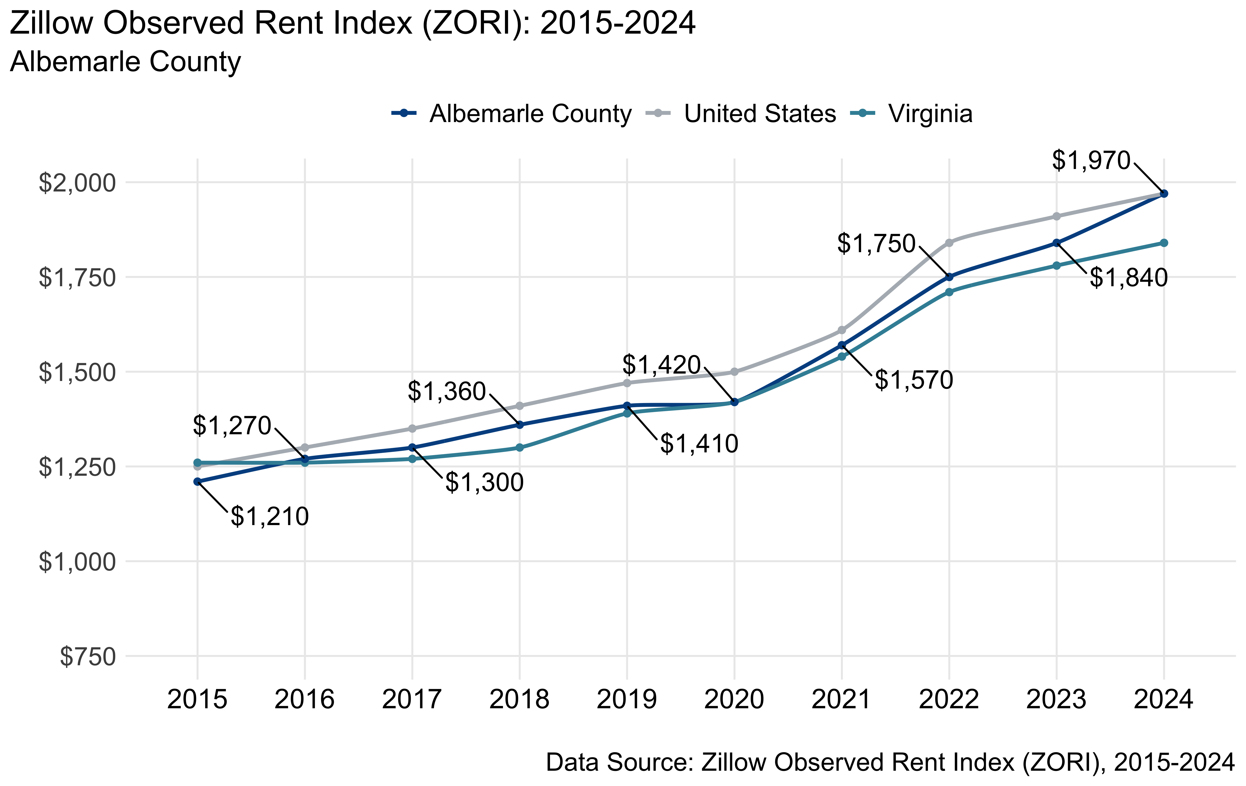

Figure 5.6: Zillow Observed Rent Index (ZORI): 2015-2024. Monthly rent in Albemarle County has steadily increased from $1,210 in 2015 to $1,970 in 2024.

Many residents face economic hardship over rising rents, but these burdens are not equally shared. Statewide, rising rents have been a key focus of grassroots political advocacy efforts, and two bills were proposed in Virginia’s General Assembly in 2024 to permit localities to pursue rent control measures (though neither bill advanced).[75]

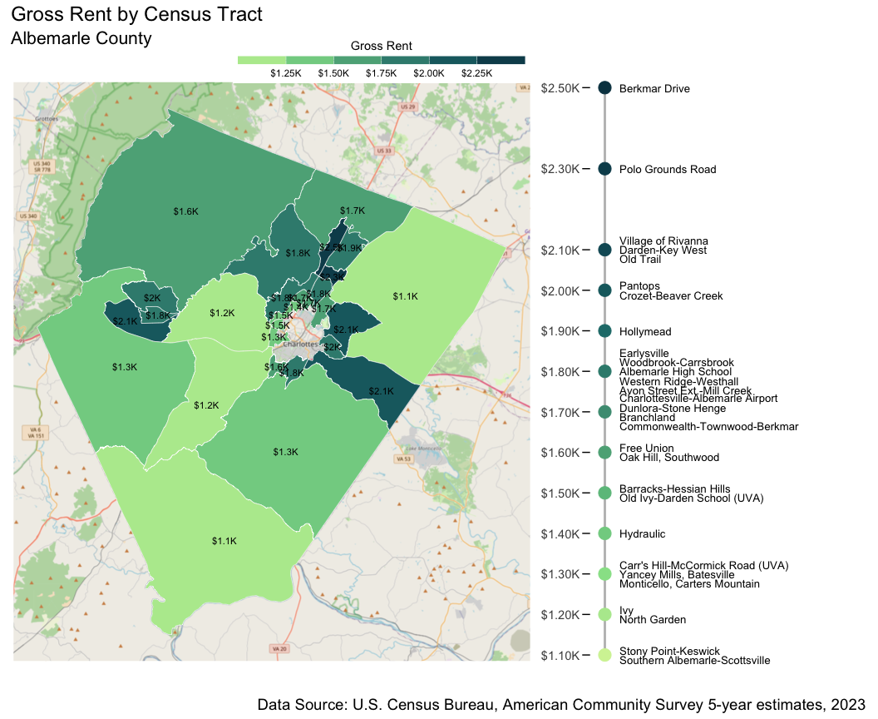

Figure 5.7: Gross Rent by Census Tract, 2023. Monthly rents vary in the county from $1,100 to $2,500.

Rent varies between neighborhoods in Albemarle County, with the median rent ranging from $1,100 in Stony Point-Keswick and Southern Albemarle to $2,500 around Berkmar Drive and $2,300 in the Polo Grounds Road area (Figure 5.7).

The impact of high rental costs on economic security is evident in estimates of how much of a household’s income goes towards housing. A household is considered to be rent burdened if 30% or more of their monthly income is spent on housing. If these costs are over 50% of household income, they are considered severely burdened by the cost of housing. The number of rent burdened households varies geographically across census tracts in Albemarle (Figure 5.8).

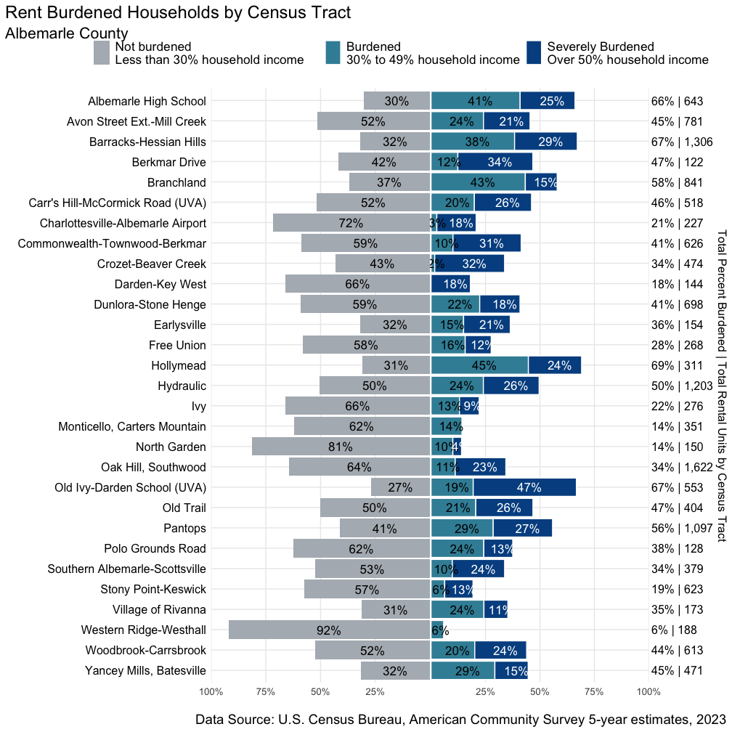

Figure 5.8: Rent Burdened Households by Census Tract, 2023. The percent of households that are rent burdened ranges from 6% in Western Ridge-Westhall to 69% in Hollymead.

In Albemarle County, there are seven tracts where half or more renters are burdened by housing costs: Albemarle High School (66%), Barracks-Hessian Hills (67%), Branchland (58%), Hollymead (69%), Hydraulic (50%), Old Ivy-Darden School (UVA) (67%), and Pantops (56%). There are many neighborhoods where significant proportions face severe rent burden. Housing constitutes an increasingly burdensome and unaffordable element of the cost of living for many Albemarle County residents.

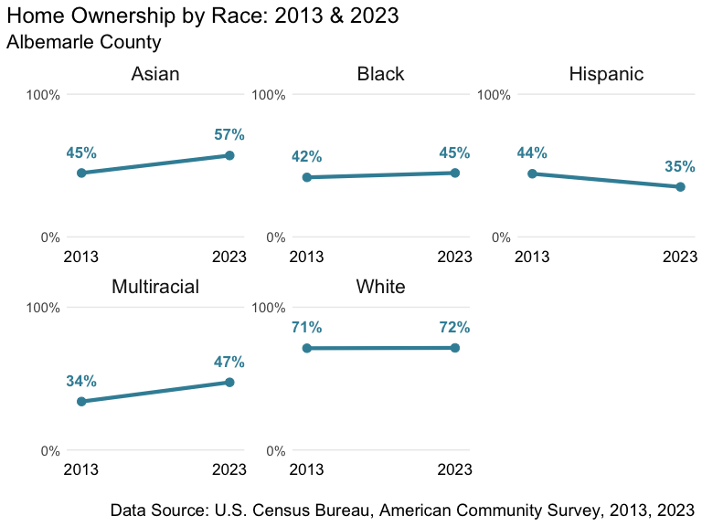

Figure 5.9: Home Ownership by Race: 2013 & 2023.

While home ownership remained relatively steady over the past decade, with 66% of households owning their residence, there was modest growth in homeownership among Black and Asian-identified residents.[76] Overall, white residents remain markedly more likely to own homes compared to most other racial groups. In 2023, 45% of Black residents and 35% of Hispanic residents were homeowners, compared to 72% of white residents. Notably, Hispanic residents are the only racial group to see a decline in homeownership rates in the last ten years. Addressing disparities in home ownership rates is critical for ensuring equitable access to economic stability and wealth-building opportunities for all Albemarle residents.

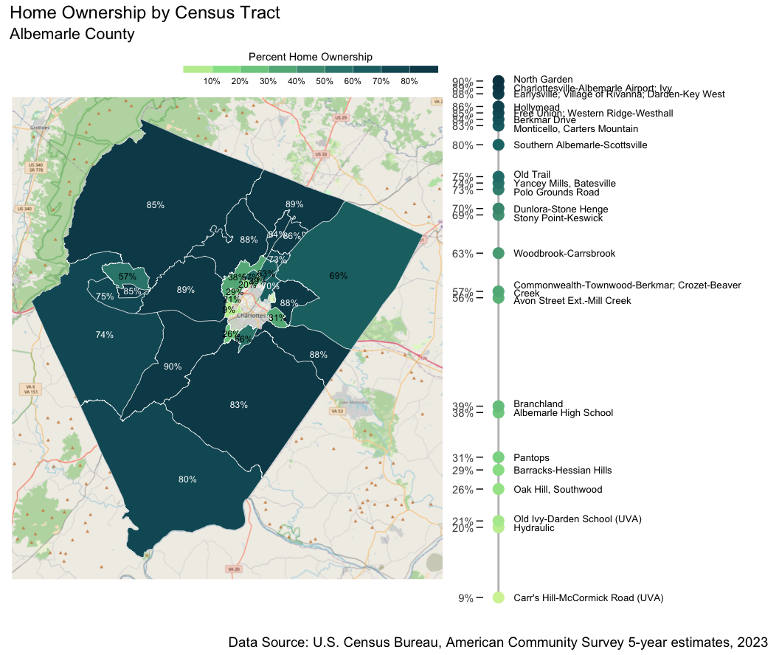

Figure 5.10: Home Ownership by Census Tract, 2023. Many tracts have homeownership rates between 80% and 98%. Lower rates of homeownership occur in tracts bordering the City of Charlottesville.

Home ownership also varies geographically, ranging from a low of 9% in the Carr’s Hill-McCormick Road area to 90% in North Garden. In most tracts in the county, between 69% and 90% of residents own their homes.

Albemarle County is in the process of updating its Comprehensive Plan which will guide new policies to address challenges like housing. Given expected population growth, the Comprehensive Plan[77] and recently approved Housing Albemarle Policy[78] are pursuing higher density and a diversity of housing development to meet current and future needs.

Relatedly, the region experienced a significant increase in people experiencing homelessness post-COVID, with 266 unhoused people in 2022.[79] That number has fallen to 125 in 2024,[80] but likely undercounts the true number of people experiencing homelessness.[81] As a regional challenge, the report for the combined Charlottesville and Albemarle area addresses the data and experience of homelessness in more depth. Albemarle’s long-term policy commitments to fostering housing development, affordable and otherwise, is vital for addressing this crisis. Shorter term investments in services for our unhoused neighbors and permanent supportive housing are necessary to meet immediate community needs.

### Heirs’ Property in Albemarle County

Property ownership has long been a tool for wealth building. In addition to having lower rates of homeownership, Black families have been more likely to lose land due to the absence of a clear title, an absence that may itself be the result of exclusion from access to financial and legal systems. When property is inherited in the absence of a will, property is distributed to heirs generating multiple owners without a clear title.[82] Inheriting shares in divided property can create barriers to accessing loans and homeowner assistance programs, as well as create the risk of individual heirs initiating partition, a forced land sale impacting all other heirs.

In the Southern United States, an estimated 30-40% of Black-owned land is owned through heirs’ property.[83] Black Americans have historically been less likely to write wills: 24% compared to the national average of 57%.[84] These factors leave Black Americans who own or stand to receive heirs’ property at risk of foreclosures due to unpaid property taxes or of losing land to speculators paying low prices after partition has been initiated.

Heirs’ property is particularly common in Virginia’s rural areas: recent estimates from the Federal Reserve Bank of Richmond suggested that between 0.5% and 1% of parcels in Albemarle County were composed of heirs’ property.[85] A more comprehensive, focused study of heirs’ property in Albemarle County would provide a more accurate estimate of the prevalence of these properties in the county and provide a base for ensuring that heirs’ property owners in the county receive adequate protection from exploitation as well as access to wealth-building opportunities.

### Policy Connections

The combination of rising costs, especially around housing, and insufficient income threatens the economic security of many county residents.

Economic security and mobility is advanced through jobs that provide living wages, predictable schedules, and pathways for advancement. Virginia localities are prevented from adopting local minimum wage laws,[86] but they can partner in supporting and enforcing labor protections—from fighting wage theft to promoting organization and bargaining—that improve job quality.[87] Local investment in apprenticeship and pathway programs can help move low-earning workers into more secure employment. This can be especially impactful when leveraging the resources of anchor institutions[88] like Network2Work at Piedmont Virginia Community College and Pipelines and Pathways at the University of Virginia. New development also creates opportunities for targeted hiring[89] or community benefit agreements[90] to ensure those with the greatest need benefit from community investments.

Support for the entrepreneurial ecosystem gives residents the resources to create businesses and meaningful work. Coaching, financial assistance, and system navigation like that offered through the Office of Economic Development,[91] along with the business incubation efforts of community organizations is vital, especially in support of underrepresented entrepreneurs.

On the other side of the ledger, the rapid rise in the cost of living is a nationwide problem. Housing is by far the most significant contributor to the high living costs faced by Albemarle households, making housing policies and investments a necessity for assisting struggling households. As Albemarle County updates the Comprehensive Plan to guide new policies and plans including housing, considerations of growth and housing are paramount. Adopting land use categories consistent with high density housing is necessary to accommodate the anticipated county population growth while promoting affordable housing.[92] Given the complexity of the challenge, a range of strategies are needed.[93] Significant financial investments as well as targeted housing subsidies will help ensure that housing is affordable to lower-income people.

## Additional Community Wellbeing Profiles

The partnership between the UVA Center for Community Partnerships Albemarle County and the City of Charlottesville also produced two additional profiles:

* Charlottesville City Community Wellbeing Profile: A report with parallel information on the demographics, health, education, and living standards for the City of Charlottesville.
* Charlottesville and Albemarle Area Community Wellbeing Profile: A report that expands on the individual locality profiles with trend data for measures related to the well-being of the collective population of the City of Charlottesville and Albemarle County.

## Contributors

This report was done in partnership between the UVA Center for Community Partnerships and Albemarle County. The collaborators on this report are:

* Michele Claibourn, Director of Community-Centered Analysis, Center for Community Partnerships, University of Virginia and Assistant Professor, Batten School of Leadership and Public Policy, University of Virginia; project direction, report writing, data collection
* Elizabeth Mitchell, Senior Research Specialist, Center for Community Partnerships, University of Virginia; data collection, data visualization, report writing
* Henry DeMarco, Center for Community Partnerships Data Fellow; report writing, data acquisition
* Sherica Jones-Lewis, Director of Community Research, Center for Community Partnerships, University of Virginia; project guidance, report review and editing
* Jess Harris, Assistant Director of Community Research, Center for Community Partnerships, University of Virginia; report review and editing
* Jesse Brookins, Director, Albemarle County; project guidance and report review
* Tamara Ryan, Coordinator, Albemarle County; project guidance and report review

### The UVA Center for Community Partnerships

Established in 2019, the mission of the UVA Center for Community Partnerships is to build mutually beneficial partnerships in university communities by advancing a transformative approach to the fundamental research mission, which will, in turn, reform institutional values, pedagogy, and operations. We envision universities that serve local communities by bringing rich research resources to bear and equipping students to lead in building a more just society.

Community-Centered Analysis centers on community-driven partnerships to provide advocates, as well as civic and private sector leaders, with data and metrics, contextualized analysis, interactive maps and data visualizations, and narrative storytelling as a resource in pursuit of a more just region.

### Project Repository

The work supporting the Community Wellbeing Profiles, including our data collection documentation and the corresponding data, is publicly available on GitHub at https://github.com/virginiaequitycenter/regional-equity-profile/tree/main

This work is licensed under a Creative Commons Attribution 4.0 International License.

## Appendix

### AHDI Albemarle County Census Tracts 2023 vs 2019 (All Dimensions)

**Table 6:** **American Human Development Index: Albemarle County Census Tracts 2023 vs 2019 (All Dimensions)**

| **AHDI 2023 Profile** | | | | | | | | | **AHDI 2019 Profile** | | | | | | | | |
| --- | --- | --- | --- | --- | --- | --- | --- | --- | --- | --- | --- | --- | --- | --- | --- | --- | --- |
| Census Tract (2023) | Tract Name (2023) | Life Expectancy (2023) | At Least High School Diploma (2023) | At Least Bachelor’s Degree (2023) | Graduate Degree (2023) | School Enrollment (2023) | Median Earnings (2023 $) | **AHDI 2023** | **AHDI 2019** | Life Expectancy (2019) | At Least High School Diploma (2019) | At Least Bachelor’s Degree (2019) | Graduate Degree (2019) | School Enrollment (2019) | Median Earnings (2019 $) | Tract Name (2019) | Census Tract (2019) |
| 101 | Free Union | 84 | 93% | 64% | 33% | 82% | $63,313 | **8.0** | **7.2** | 84 | 93% | 48% | 21% | 85% | $45,449 | Free Union | 101 |
| 102.01 | Charlottesville-Albemarle Airport | 77 | 96% | 57% | 29% | 83% | $65,500 | **7.0** | **6.3** | 77 | 95% | 50% | 24% | 90% | $42,083 | Charlottesville-Albemarle Airport | 102.01 |
| 102.02 | Earlysville | 81 | 99% | 72% | 41% | 92% | $76,116 | **8.6** | **8.2** | 81 | 96% | 70% | 42% | 92% | $58,380 | Earlysville | 102.02 |
| 103.01 | Berkmar Drive | 82 | 97% | 58% | 30% | 70% | $66,442 | **7.3** | **7.1** | 82 | 92% | 53% | 24% | 83% | $48,022 | Hollymead | 103 |
| 103.02 | Polo Grounds Road | 82 | 96% | 71% | 38% | 92% | $90,723 | **9.1** |
| 103.03 | Hollymead | 82 | 97% | 51% | 23% | 91% | $60,974 | **7.6** |
| 104.01 | Stony Point-Keswick | 81 | 90% | 52% | 19% | 76% | $58,791 | **6.7** | **5.8** | 81 | 91% | 45% | 20% | 65% | $41,712 | Stony Point and Keswick | 104.01 |
| 104.02 | Village of Rivanna | 84 | 97% | 70% | 38% | 91% | $66,616 | **8.6** | **7.8** | 84 | 92% | 62% | 28% | 87% | $50,270 | Village of Rivanna | 104.02 |
| 105.01 | Darden-Key West | 83 | 96% | 69% | 34% | 83% | $65,159 | **8.1** | **7.7** | 83 | 93% | 63% | 29% | 87% | $50,673 | Pantops | 105 |
| 105.02 | Pantops | 83 | 97% | 75% | 41% | 92% | $71,133 | **8.7** |
| 106.03 | Branchland | 80 | 88% | 52% | 21% | 56% | $48,398 | **5.5** | **5.7** | 80 | 90% | 52% | 30% | 65% | $38,500 | Branchland to Carrsbrook | 106.01 |
| 106.04 | Woodbrook-Carrsbrook | 80 | 98% | 69% | 38% | 79% | $55,392 | **7.2** |
| 106.02 | Dunlora-Stone Henge | 80 | 99% | 73% | 39% | 94% | $75,956 | **8.6** | **7.1** | 80 | 97% | 66% | 30% | 84% | $45,683 | Pen Park-Dunlora | 106.02 |
| 107.01 | Hydraulic | 77 | 94% | 45% | 19% | 53% | $40,372 | **4.5** | **5.0** | 77 | 88% | 41% | 20% | 71% | $36,280 | Commonwealth-Hydraulic | 107 |
| 107.02 | Commonwealth-Townwood-Berkmar | 77 | 88% | 37% | 17% | 80% | $47,879 | **5.5** |
| 108.01 | Barracks-Hessian Hills | 83 | 89% | 49% | 25% | 76% | $36,289 | **5.9** | **6.3** | 83 | 92% | 56% | 22% | 75% | $37,215 | Albemarle High School | 108 |
| 108.02 | Albemarle High School | 83 | 94% | 46% | 27% | 72% | $35,724 | **5.8** |
| 109.01 | Old Ivy-Darden School (UVA) | 79 | 99% | 86% | 35% | 98% | $12,409 | **4.4** | **4.8** | 79 | 100% | 91% | 36% | 96% | $12,500 | UVA campus - Darden School, JPJ Arena | 109.01 |
| 110 | Ivy | 86 | 97% | 82% | 41% | 96% | $103,750 | **10.3** | **9.1** | 86 | 97% | 79% | 48% | 90% | $57,656 | Ivy | 110 |
| 111.01 | Crozet-Beaver Creek | 81 | 95% | 63% | 31% | 97% | $55,724 | **7.7** | **8.0** | 81 | 96% | 64% | 32% | 94% | $56,333 | Crozet | 111 |
| 111.02 | Western Ridge-Westhall | 81 | 97% | 78% | 38% | 78% | $83,036 | **8.4** |
| 111.03 | Old Trail | 81 | 97% | 72% | 40% | 93% | $80,341 | **8.7** |
| 112.01 | Yancey Mills, Batesville | 78 | 95% | 57% | 30% | 80% | $47,358 | **6.4** | **6.1** | 78 | 92% | 51% | 22% | 83% | $39,931 | Yancey Mills, Batesville | 112.01 |
| 112.02 | North Garden | 87 | 95% | 68% | 48% | 93% | $76,599 | **9.5** | **9.3** | 87 | 95% | 68% | 37% | 93% | $64,965 | North Garden | 112.02 |
| 113.01 | Monticello, Carters Mountain | 84 | 94% | 43% | 20% | 84% | $47,627 | **6.9** | **5.8** | 84 | 86% | 37% | 13% | 71% | $35,245 | Monticello, Carters Mountain | 113.01 |
| 113.02 | Oak Hill, Southwood | 76 | 89% | 59% | 28% | 68% | $42,507 | **5.2** | **4.7** | 76 | 87% | 44% | 22% | 75% | $30,723 | Oak Hill, Old Lynchburg Rd | 113.02 |
| 113.03 | Avon Street Ext.-Mill Creek | 80 | 95% | 65% | 29% | 80% | $58,073 | **7.1** | **6.0** | 80 | 91% | 60% | 31% | 65% | $40,788 | Avon Street Extended | 113.03 |
| 114 | Southern Albemarle-Scottsville | 79 | 87% | 40% | 18% | 70% | $44,646 | **5.4** | **5.1** | 79 | 86% | 28% | 9% | 82% | $32,716 | Southern Albemarle | 114 |
| Data Sources: *Life Expectancy:* County Health Rankings, 2020 & 2024. *Education and Earnings:* U.S. Census Bureau, American Community Survey 5-year estimates, 2019; 2023. | | | | | | | | | | | | | | | | | |

### 

### Data Sources by Figure/Table

| Figure | Source |
| --- | --- |
| Demographic Profile | |
| Figure 1.1: White and Non-White Population Composition, 1900-2020. | U.S. Census Bureau. Race, U.S. Decennial Census 1900-2020. Prepared by Social Explorer. |
| Figure 1.2: Population Composition by Race & Ethnicity, 2013-2023. | U.S. Census Bureau. "Hispanic or Latino Origin by Race." American Community Survey, ACS 5-Year Estimates Detailed Tables, Table B03002, 2023, data.census.gov/table/ACSDT5Y2023.B03002?q=B03002&g=050XX00US51003,51540. |
| Figure 1.3: Age of Residents: 2013 vs 2023. | U.S. Census Bureau. "Sex by Age." American Community Survey, ACS 5-Year Estimates Detailed Tables, Table B01001, 2013 & 2023, data.census.gov/table/ACSDT5Y2023.B01001?q=B01001&g=050XX00US51003,51540. |
| Figure 1.4: Sex by Age Group, 2023. | U.S. Census Bureau. "Sex by Age." American Community Survey, ACS 5-Year Estimates Detailed Tables, Table B01001, 2013 & 2023, data.census.gov/table/ACSDT5Y2023.B01001?q=B01001&g=050XX00US51003,51540. |
| Figure 1.5: Nativity of Residents, 2023. | U.S. Census Bureau. "Nativity and Citizenship Status in the United States." American Community Survey, ACS 5-Year Estimates Detailed Tables, Table B05001, 2023, data.census.gov/table/ACSDT5Y2023.B05001?q=B05001&g=050XX00US51003,51540. |
| Figure 1.6: Residents Born Outside the US by Place of Birth, 2023. | U.S. Census Bureau. "Place of Birth for the Foreign-Born Population in the United States." American Community Survey, ACS 5-Year Estimates Detailed Tables, Table B05006, 2023, data.census.gov/table/ACSDT5Y2023.B05006?q=B05006&g=050XX00US51003,51540. |
| Figure 1.7: Limited & Non-Limited English Speaking Households, 2023. | U.S. Census Bureau. "Detailed Household Language by Household Limited English Speaking Status." American Community Survey, ACS 5-Year Estimates Detailed Tables, Table B16002, 2023, data.census.gov/table/ACSDT5Y2023.B16002?q=B16002&g=050XX00US51003,51540. |
| Figure 1.8: Limited & Non-Limited English Speaking Households by Language, 2023. | U.S. Census Bureau. "Detailed Household Language by Household Limited English Speaking Status." American Community Survey, ACS 5-Year Estimates Detailed Tables, Table B16002, 2023, data.census.gov/table/ACSDT5Y2023.B16002?q=B16002&g=050XX00US51003,51540. |
| Figure 1.9: Disability Status by Age Group, 2023. | U.S. Census Bureau. "Sex by Age by Disability Status." American Community Survey, ACS 5-Year Estimates Detailed Tables, Table B18101, 2023, data.census.gov/table/ACSDT5Y2023.B18101?q=B18101&g=050XX00US51003,51540. |
| Figure 1.10: Number of people identifying as having a particular disability, 2023. | U.S. Census Bureau. "Sex by Age by Hearing Difficulty." American Community Survey, ACS 5-Year Estimates Detailed Tables, Table B18102, 2023, data.census.gov/table/ACSDT5Y2023.B18102?q=B18102&g=050XX00US51003,51540.; U.S. Census Bureau. "Sex by Age by Vision Difficulty." American Community Survey, ACS 5-Year Estimates Detailed Tables, Table B18103, 2023, data.census.gov/table/ACSDT5Y2023.B18103?q=B18103&g=050XX00US51003,51540. ; U.S. Census Bureau. "Sex by Age by Cognitive Difficulty." American Community Survey, ACS 5-Year Estimates Detailed Tables, Table B18104, 2023, data.census.gov/table/ACSDT5Y2023.B18104?q=B18104&g=050XX00US51003,51540.; U.S. Census Bureau. "Sex by Age by Ambulatory Difficulty." American Community Survey, ACS 5-Year Estimates Detailed Tables, Table B18105, 2023, data.census.gov/table/ACSDT5Y2023.B18105?q=B18105&g=050XX00US51003,51540.; U.S. Census Bureau. "Sex by Age by Self-Care Difficulty." American Community Survey, ACS 5-Year Estimates Detailed Tables, Table B18106, 2023, data.census.gov/table/ACSDT5Y2023.B18106?q=B18106&g=050XX00US51003,51540. ; U.S. Census Bureau. "Sex by Age by Independent Living Difficulty." American Community Survey, ACS 5-Year Estimates Detailed Tables, Table B18107, 2023, data.census.gov/table/ACSDT5Y2023.B18107?q=B18107&g=050XX00US51003,51540. |
| AHDI | |
| Table 1: American Human Development Index: Comparison Across Benchmark Localities | Life Expectancy: "Virginia Data and Resources." County Health Rankings, www.countyhealthrankings.org/health-data/virginia/data-and-resources. Educational Attainment: U.S. Census Bureau. "Educational Attainment." American Community Survey, ACS 5-Year Estimates Subject Tables, Table S1501, 2023, data.census.gov/table/ACSST5Y2023.S1501?q=S1501&g=050XX00US51003,51540. School Enrollment: U.S. Census Bureau. "School Enrollment." American Community Survey, ACS 5-Year Estimates Subject Tables, Table S1401, 2023, data.census.gov/table/ACSST5Y2023.S1401?q=S1401&g=050XX00US51003,51540. Median Personal Earnings: U.S. Census Bureau. "Median Earnings in the Past 12 Months (in 2023 Inflation-Adjusted Dollars) by Sex for the Population 16 Years and Over With Earnings in the Past 12 Months." American Community Survey, ACS 5-Year Estimates Detailed Tables, Table B20002, 2023, https://data.census.gov/table/ACSDT5Y2023.B20002?q=B20002&g=050XX00US51003,51540. |
| Table 2: American Human Development Index: 2023 vs 2019 | See Sources for Table 1 |
| Figure 2.1: American Human Development Index by Census Tract. | See Sources for Table 1 |
| Figure 2.2: Dimensions of the American Human Development Index by Census Tract. | See Sources for Table 1 |
| Table 3: American Human Development Index: Albemarle County Census Tracts 2023 vs 2019 | See Sources for Table 1 |
| Health Profile | |
| Figure 3.1: Life Expectancy by Race, 2024. | "Virginia Data and Resources." County Health Rankings, www.countyhealthrankings.org/health-data/virginia/data-and-resources |
| Figure 3.2: Average Life Expectancy by Census Tract. | "Virginia Data and Resources." County Health Rankings, www.countyhealthrankings.org/health-data/virginia/data-and-resources |
| Figure 3.3: Food Insecurity Rates in Albemarle County, 2022. | Dewey, A., Harris, V., Hake, M., & Engelhard, E. (2024). Map the Meal Gap 2024: An Analysis of County and Congressional District Food Insecurity and County Food Cost in the United States in 2022. Feeding America. www.feedingamerica.org/research/map-the-meal-gap/by-county |
| Table 4: Health Outcomes by Census Tract | PLACES: Local Data for Better Health, Census Tract Data 2024 release. Centers for Disease Control and Prevention, National Center for Chronic Disease Prevention and Health Promotion, Division of Population Health. https://data.cdc.gov/500-Cities-Places/PLACES-Local-Data-for-Better-Health-Census-Tract-D/cwsq-ngmh/about_data |
| Table 5: Health Prevention Measures by Census Tract | See Source for Table 4 |
| Figure 3.4: Residents with No Health Insurance by Race, 2023. | U.S. Census Bureau. "Selected Characteristics of Health Insurance Coverage in the United States." American Community Survey, ACS 5-Year Estimates Subject Tables, Table S2701, 2023, data.census.gov/table/ACSST5Y2023.S2701?q=S2701&g=050XX00US51003,51540. |
| Figure 3.5: Residents with No Health Insurance by Census Tract, 2023. | U.S. Census Bureau. "Selected Characteristics of Health Insurance Coverage in the United States." American Community Survey, ACS 5-Year Estimates Subject Tables, Table S2701, 2023, data.census.gov/table/ACSST5Y2023.S2701?q=S2701&g=050XX00US51003,51540. |
| Figure 3.6: EMS Responses to Opioid Overdoses by Census Tract: 12/1/16-7/10/24. | Data prepared by Albemarle County Fire Rescue for 2019-2023 |
| Education Profile | |
| Figure 4.1: Educational Attainment by Race/Ethnicity for the population 25 years and over, 2023. | U.S. Census Bureau. "Educational Attainment." American Community Survey, ACS 5-Year Estimates Subject Tables, Table S1501, 2023, data.census.gov/table/ACSST5Y2023.S1501?q=S1501&g=050XX00US51003,51540. |
| Figure 4.2: Education Level: Bachelor’s Degree or Higher by Census Tract for the population 25 years and older, 2023. | U.S. Census Bureau. "Educational Attainment." American Community Survey, ACS 5-Year Estimates Subject Tables, Table S1501, 2023, data.census.gov/table/ACSST5Y2023.S1501?q=S1501&g=050XX00US51003,51540. |
| Figure 4.3: School Enrollment (Ages 3-24) by Census Tract, 2023. | U.S. Census Bureau. "School Enrollment." American Community Survey, ACS 5-Year Estimates Subject Tables, Table S1401, 2023, data.census.gov/table/ACSST5Y2023.S1401?q=S1401&g=050XX00US51003,51540. |
| Figure 4.4: AP & Dual Enrollment in ACPS, 2023-2024. | Advanced Programs. Virginia Department of Education (VDOE). www.doe.virginia.gov/data-policy-funding/data-reports/program-participation-data/advanced-programs |
| Figure 4.5: Short Term Suspension Incidents by Race/Ethnicity in ACPS, 2023-2024. | School Quality Profiles. Virginia Department of Education (VDOE). schoolquality.virginia.gov/download-data |
| Figure 4.6: Chronic Absenteeism in ACPS, 2023-2024. | School Quality Profiles. Virginia Department of Education (VDOE). schoolquality.virginia.gov/download-data |
| Living Standards and Housing Profile | |
| Figure 5.1: Median Personal Earnings by Sex and Race, 2023. | U.S. Census Bureau. "Median Earnings in the Past 12 Months (in 2023 Inflation-Adjusted Dollars) by Sex by Work Experience in the Past 12 Months for the Population 16 Years and Over With Earnings in the Past 12 Months." American Community Survey, ACS 5-Year Estimates Detailed Tables, Tables B20017A-I, 2023, data.census.gov/table/ACSDT5Y2023.B20017?q=B20017&g=050XX00US51003,51540. |
| Figure 5.2: Median Household Income by Census Tract, 2023. | U.S. Census Bureau. "Median Household Income in the Past 12 Months (in 2023 Inflation-Adjusted Dollars)." American Community Survey, ACS 5-Year Estimates Detailed Tables, Table B19013, 2023, data.census.gov/table/ACSDT5Y2023.B19013?q=B19013&g=050XX00US51003,51540. |
| Figure 5.3: Median Household Income by Race/Ethnicity, 2023. | U.S. Census Bureau. "Median Household Income in the Past 12 Months (in 2023 Inflation-Adjusted Dollars)." American Community Survey, ACS 5-Year Estimates Detailed Tables, Table B19013A-I, 2023, data.census.gov/table/ACSDT5Y2023.B19013?q=B19013&g=050XX00US51003,51540. |
| Figure 5.4: ALICE Thresholds 2010-2022. | United for Alice. www.unitedforalice.org/state-overview/Virginia |
| Figure 5.5: ALICE Households by Race/Ethnicity, 2022. | United for Alice. www.unitedforalice.org/state-overview/Virginia |
| Figure 5.6: Zillow Observed Rent Index (ZORI): 2015-2024. | Zillow Observed Rent Index (ZORI). Housing Data. Zillow. www.zillow.com/research/data/ |
| Figure 5.7: Gross Rent by Census Tract, 2023. | U.S. Census Bureau. "Median Gross Rent (Dollars)." American Community Survey, ACS 5-Year Estimates Detailed Tables, Table B25064, 2023, data.census.gov/table/ACSDT5Y2023.B25064?q=B25064&g=050XX00US51003,51540. |
| Figure 5.8: Rent Burdened Households by Census Tract, 2023. | U.S. Census Bureau. "Gross Rent as a Percentage of Household Income in the Past 12 Months." American Community Survey, ACS 5-Year Estimates Detailed Tables, Table B25070, 2023, data.census.gov/table/ACSDT5Y2023.B25070?q=B25070&g=050XX00US51003,51540. |
| Figure 5.9: Home Ownership by Race: 2013 & 2023. | U.S. Census Bureau. "Tenure." American Community Survey, ACS 5-Year Estimates Detailed Tables, Table B25003A-I, 2013 & 2023, data.census.gov/table/ACSDT5Y2023.B25003?q=B25003&g=050XX00US51003,51540. |
| Figure 5.10: Home Ownership by Census Tract, 2023. | U.S. Census Bureau. "Tenure." American Community Survey, ACS 5-Year Estimates Detailed Tables, Table B25003, 2023, data.census.gov/table/ACSDT5Y2023.B25003?q=B25003&g=050XX00US51003,51540. |
| Appendix | |
| Table 6: American Human Development Index: Albemarle County Census Tracts 2023 vs 2019 (All Dimensions) | See Sources for Table 1 |

1. County Executive Department, Albemarle County. <https://www.albemarle.org/government/county-executive>
2. University of Virginia Weldon Cooper Center for Public Service. (2024). Virginia Population Estimates. Retrieved from <https://coopercenter.org/virginia-population-estimates>.
3. Hantman, Jeffrey L. Monacan Millennium: A Collaborative Archaeology and History of a Virginia Indian People. University of Virginia Press, 2018.
4. “The Great Migration (1910-1970). National Archives, ”<https://www.archives.gov/research/african-americans/migrations/great-migration>
5. Proffit Historic District. Virginia Department of Historic Resources. <https://www.dhr.virginia.gov/historic-registers/002-5019/>
6. Proffit Historic District Online Resource Archive. Carter G. Woodson Institute for Afro-American and African Studies at the University of Virginia. <http://www2.vcdh.virginia.edu/afam/proffit/>
7. U.S. Census Bureau, U.S. Department of Commerce. "ACS Demographic and Housing Estimates." American Community Survey, ACS 5-Year Estimates Data Profiles, Table DP05, 2023, https://data.census.gov/table/ACSDP5Y2023.DP05?q=population&g=050XX00US51003,51540.
8. “Race.” National Human Genome Research Institute, https://www.genome.gov/genetics-glossary/Race
9. “Why We Ask Questions About Race.” American Community Survey (ACS), United States Census Bureau, <https://www.census.gov/acs/www/about/why-we-ask-each-question/race/>
10. "Middle Eastern or North African." U.S. Office of Management and Budget and the U.S. Census Bureau, https://spd15revision.gov/content/spd15revision/en/history/2024-standards/proposals/mena.html
11. <https://news.virginia.edu/content/population-projections-show-virginia-aging-growing-more-slowly>
12. Currently, the U.S. Census data only asks individuals about their biological sex, including only the binary options for male and female, and does not include questions on gender identity. A vibrant and active community that represents a fuller range of gender identities calls the county home.
13. These regions are defined by the U.S. Census Bureau for this specific measure and include countries that might not typically be defined in these ways, i.e. Jamaica is a Caribbean country, while the entire Caribbean region is defined as part of Latin America. For a complete breakdown by region and country see the following census table: https://data.census.gov/table/ACSDT5Y2022.B05006?q=B05006&g=050XX00US51003,51540
14. Paul Siegel, Elizabeth Martin, and Rosalind Bruno. “Language Use and Linguistic

    Isolation: Historical Data and Methodological Issues.” Statistical Policy Working

    Paper, United States Census Bureau. <https://www.census.gov/library/working-papers/2007/adrm/ssm2007-02.html>
15. U.S. Census Bureau (2019-2023). *Sex by Age by Disability Status American Community Survey 5-year estimates.* Retrieved from https://censusreporter.org/data/table/?table=B18101&geo_ids=05000US51540,05000US51003&primary_geo_id=05000US51540
16. Karpman, Michael and Morriss, Sarah. “Current Approaches to Measuring Disability Status in Federal Surveys May Limit Understanding of Economic and Health Disparities.” Urban Institute, June 27, 2024, <https://www.urban.org/research/publication/current-approaches-measuring-disability-status-federal-surveys-may-limit>
17. Gender and Sexual Orientation. Office of Equity and Inclusion, Albemarle County, Virginia. <https://engage.albemarle.org/21-day-equity-challenge/news_feed/gender-and-sexual-orientation>
18. See Flores, A.R. & Conron, K.J. (2023). Adult LGBT Population in the United States. The Williams Institute, UCLA, Los Angeles, CA. <https://williamsinstitute.law.ucla.edu/publications/adult-lgbt-pop-us/> and Julian, C. A. (2023). Geographic variation in LGBT+ identification in the U.S. Family Profiles, FP-23-05. National Center for Family & Marriage Research. https://doi.org/10.25035/ncfmr/fp-23-05
19. U.S. Census Bureau. "Household Type (Including Living Alone) by Relationship." American Community Survey, ACS 1-Year Estimates Detailed Tables, Table B09019, 2023, data.census.gov/table/ACSDT1Y2023.B09019?q=b09019&g=050XX00US51003,51540.
20. Deng, Beyond and Watson, Tara. (2023). LGBTQ+ data availability What we can learn from four major surveys. The Brookings Institution. <https://www.brookings.edu/articles/lgbtq-data-availability-what-we-can-learn-from-four-major-surveys/>
21. Measuring Sexual Orientation and Gender Identity on the American Community Survey. (2023). Working Paper, Economic Commission for Europe, Conference of European Statisticians. <https://unece.org/sites/default/files/2023-04/D3_WP13_Roberts_EN.pdf>; and Work to Measure Sexual Orientation and Gender Identity (SOGI) at the Census Bureau. United States Census Bureau. <https://www.census.gov/content/dam/Census/newsroom/press-kits/2024/paa/paa2024-presentation-sexual-orientation-gender-identity.pdf>. Archived Access: <https://web.archive.org/web/20250131213905/https://www.census.gov/content/dam/Census/newsroom/press-kits/2024/paa/paa2024-presentation-sexual-orientation-gender-identity.pdf>. As of February 2024, these efforts have been stalled in response to the current presidential administration.
22. McGahey, Richard, et al. (2023). Measuring What Matters for Racial Progress: Local and State Innovation in Racial Equity Impact Assessment. Institute on Race, Power and Political Economy at The New School and Brookings Metro. <https://racepowerpolicy.org/measuring-what-matters/>
23. Comprehensive Policy Approaches to Support the Aging Population. (2021). National Conference of State Legislatures (NCSL). <https://www.ncsl.org/health/comprehensive-policy-approaches-to-support-the-aging-population>
24. Sugiyama M, et al. Third Places for Older Adults' Social Engagement: A Scoping Review and Research Agenda. Gerontologist. 2023 Aug 24;63(7):1149-1161. https://pubmed.ncbi.nlm.nih.gov/36512515/
25. Lin D, Cui J. Transport and Mobility Needs for an Ageing Society from a Policy Perspective: Review and Implications. Int J Environ Res Public Health. 2021 Nov 10;18(22):11802. <https://www.ncbi.nlm.nih.gov/pmc/articles/PMC8625775/>
26. Dana Ferrante, Taylor Carty. Seven Ways Federal Policymakers Can Improve the Lives of Disabled People. Urban Institute, July 17, 2024.

    <https://www.urban.org/urban-wire/seven-ways-federal-policymakers-can-improve-lives-disabled-people>
27. Artieda, Luis, et al. (2022). Access and Persons with Disabilities in Urban Areas. ITDP. <https://itdp.org/wp-content/uploads/2022/02/EXECUTIVE-SUMMARY-22feb-2.pdf>
28. Bicycle and pedestrian treatments. Virginia Department of Transportation. <https://www.vdot.virginia.gov/doing-business/technical-guidance-and-support/transportation-and-mobility-planning/bicycle-and-pedestrian-accommodations/bicycle-and-pedestrian-treatments/>
29. ADA Accessibility and Compliance. Albemarle County. <https://www.albemarle.org/government/facilities-environmental-services/ada-accessibility-and-compliance>
30. Hofstetter, Jacob, Margie McHugh, and Anna O’Toole. 2021. A Framework for Language Access: Key Features of U.S. State and Local Language Access Laws and Policies. Washington, DC: Migration Policy Institute. <https://www.immigrationresearch.org/system/files/A%20Framework%20for%20Language%20Access%20-%20Key%20Features%20of%20U.S.%20State%20and%20Local%20Language%20Access%20Laws%20and%20Policies.pdf>
31. Language Access: Translation and Interpretation Policies and Practices. Migration Policy Institute. <https://www.migrationpolicy.org/programs/language-access-translation-and-interpretation-policies-and-practices>
32. Hamutal Bernstein, Dulce Gonzalez, Paola Echave, and Diana Guelespe. Immigrant Families Faced Multiple Barriers to Safety Net Programs in 2021. Urban Institute. 2022. <https://www.urban.org/sites/default/files/2022-11/Immigrant%20Families%20Faced%20Multiple%20Barriers%20to%20Safety%20Net%20Programs%20in%202021.pdf>.
33. § 46.2-328.3. Driver privilege cards and permits. Code of Virginia. <https://law.lis.virginia.gov/vacode/title46.2/chapter3/section46.2-328.3/>
34. National Map of Local Entanglement with ICE. Immigrant Legal Resource Center. <https://www.ilrc.org/resources/national-map-local-entanglement-ice>
35. About Human Development. Measure of America of the Social Science Research Council. https://measureofamerica.org/human-development/
36. Social Determinants of Health. US Centers for Disease Control and Prevention. <https://www.cdc.gov/public-health-gateway/php/about/social-determinants-of-health.html>
37. This approach also departs from methods that focus primarily on those living in poverty, which may inadvertently reinforce the sense that these conditions are not relevant to all of us.
38. See the Measure of America Methodological Notes for the complete methodology: https://measureofamerica.org/wp-content/uploads/2010/11/The-Measure-of-America-2010-2011-Methodological-Notes.pdf
39. Juday, Luke and Rorem, Annie. How to modify poverty calculations for college towns. 2016. Weldon Cooper Center for Public Service, University of Virginia. https://www.coopercenter.org/research/how-modify-poverty-calculations-college-towns
40. Social Determinants of Health. Office of Disease Prevention and Health Promotion. https://odphp.health.gov/healthypeople/priority-areas/social-determinants-health
41. Centers for Disease Control and Prevention, “Community Health Improvement Navigator,” Last modified August 19, 2015, https://www.cdc.gov/chinav/index.html
42. Blue Ridge Health District, “MAAP2Health,” 2019, https://www.vdh.virginia.gov/content/uploads/sites/91/2019/08/2019-MAPP2Health-Report.pdf
43. USDA Economic Research Service, “Food Security—Key Statistics and Graphics,” https://www.ers.usda.gov/topics/food-nutrition-assistance/food-security-in-the-us/key-statistics-graphics/
44. Report: The Importance of Health Coverage. American Hospital Association. https://www.aha.org/guidesreports/report-importance-health-coverage
45. Pollitz, Kare, et al. (2020). Consumer Assistance in Health Insurance: Evidence of Impact and Unmet Need. KFF. <https://www.kff.org/report-section/consumer-assistance-in-health-insurance-evidence-of-impact-and-unmet-need-issue-brief/>
46. Myerson, Rebecca, et al. Personalized Telephone Outreach Increased Health Insurance Take-Up For Hard-To-Reach Populations, But Challenges Remain. Health Affairs. Vol 41, No. 1. 2022. <https://www.healthaffairs.org/doi/10.1377/hlthaff.2021.01000>
47. Hatch, Michael, et al. (2019) "Barber Shops, Salons, and Spas: The Complexity – and Simplicity – Of Implementing Outreach and Enrollment Contracts Under The Affordable Care Act," Journal of Public Management & Social Policy: Vol. 26 : No. 2 , Article 3. Available at: https://digitalscholarship.tsu.edu/jpmsp/vol26/iss2/3
48. Community health workers. County Health Rankings. <https://www.countyhealthrankings.org/strategies-and-solutions/what-works-for-health/strategies/community-health-workers>
49. Bell, Judith, et al. Access to Healthy Food and Why It Matters. Policy Link, 2013. <https://www.policylink.org/sites/default/files/GROCERYGAP_FINAL_NOV2013.pdf>
50. Caoimhe Twohig-Bennett, Andy Jones, The health benefits of the great outdoors: A systematic review and meta-analysis of greenspace exposure and health outcomes, Environmental Research, Volume 166,

    2018, Pages 628-637, <https://www.sciencedirect.com/science/article/pii/S0013935118303323>); Green space & parks. County Health Rankings. https://www.countyhealthrankings.org/strategies-and-solutions/what-works-for-health/strategies/green-space-parks
51. Razaghizad A, Windle SB, Filion KB, et al. The effect of overdose education and naloxone distribution: An umbrella review of systematic reviews. American Journal of Public Health. 2021;111(8):e1-e12.
52. Kendall, Rebecca. 2023. Overdose Prevention Resources. Help Happens Here. <https://www.cmhwcoalition.org/overdoseprevention>
53. § 18.2-251.03. Arrest and prosecution when experiencing or reporting overdoses. <https://law.lis.virginia.gov/vacodefull/title18.2/chapter7/article1/>
54. Lewis, K. and Burd-Sharps, S., “A Portrait of New York City 2018: Well-Being in The Five Boroughs and the Greater Metro Area. New York: Measure of America,” Social Science Research Council, 2018.
55. Census Bureau data on enrollment ask about elementary school, high school, college, or professional school. Public, private & homeschool are all included. This count excludes vocational, technical or business schools such as trade schools or on the job training.
56. Ying Shi, Maria Zhu, Equal time for equal crime? Racial bias in school discipline, Economics of Education Review, Volume 88, 2022, https://www.sciencedirect.com/science/article/pii/S0272775722000334
57. Sarah Mervosh and Francesca Paris. Why School Absences Have ‘Exploded’ Almost Everywhere. New York Times. March 29, 2024. [https://www.nytimes.com/interactive/2024/03/29/us/chronic-absences.html#](https://www.nytimes.com/interactive/2024/03/29/us/chronic-absences.html)
58. [https://www.doe.virginia.gov/programs-services/student-services/attendance-school-engagement](https://www.doe.virginia.gov/programs-services/student-services/attendance-school-engagement#:~:text=Chronic%20absenteeism%20is%20defined%20as,%2C%20unexcused%20absences%2C%20and%20suspensions.)
59. Social Determinants of Health: Education Access and Quality. Osmosis. 2024. <https://www.osmosis.org/blog/2024/03/21/social-determinants-of-health-education-access-and-quality>
60. Early Childhood Development and Education. Office of Disease Prevention and Health Promotion and the U.S. Department of Health and Human Services. <https://odphp.health.gov/healthypeople/priority-areas/social-determinants-health/literature-summaries/early-childhood-development-and-education> and Universal Access to Pre-K Should Be Part of Our Economic Recovery. New America, 2021. <https://www.newamerica.org/education-policy/edcentral/universal-pre-k-recovery/>
61. Childhood Education Working Group 2022 Report and Recommendations. University of Virginia. <https://prescouncil.president.virginia.edu/sites/g/files/jsddwu616/files/2023-06/Early%20Childhood%20Education%20Working%20Group%20Report%20Final_2022_12_21.pdf>
62. Liu, Jing. Disciplinary referrals, teachers, and the sources of racial disciplinary disproportionalities. Brookings. January 30, 2023 <https://www.brookings.edu/articles/disciplinary-referrals-teachers-and-the-sources-of-racial-disciplinary-disproportionalities/>
63. Nishioka, Vicki. Improving Racial Equity in School Discipline through Culturally Responsive SEL. 2021. REL Northwest. Institute of Education Sciences. https://ies.ed.gov/learn/blog/improving-racial-equity-school-discipline-through-culturally-responsive-sel
64. Liu, 2023
65. In addition to expanding access, this approach may help overcome the fear of social isolation that prevents some students of color from taking advanced courses. See: The Racial Makeup of a School’s AP Classes May Perpetuate Within-School Segregation. Urban Institute, 2023. <https://housingmatters.urban.org/research-summary/racial-makeup-schools-ap-classes-may-perpetuate-within-school-segregation>
66. AP, IB, and Cambridge Exam Fee Reduction Program. Item 124 #10h. Virginia General Assembly. <https://budget.lis.virginia.gov/amendment/2024/1/HB30/Introduced/CA/124/10h/>
67. Chatterji, Roby, et al. Closing Advanced Coursework Equity Gaps for All Students. 2021. American Progress. <https://www.americanprogress.org/wp-content/uploads/sites/2/2021/07/AdvancedCoursework-report1.pdf>
68. Enrollment in Higher Education. Office of Disease Prevention and Health Promotion and the U.S. Department of Health and Human Services. <https://odphp.health.gov/healthypeople/priority-areas/social-determinants-health/literature-summaries/enrollment-higher-education>
69. Pathways to Opportunity: The Virginia Plan for Higher Education Annual Report. 2021. State Council of Higher Education (SCHEV). <https://rga.lis.virginia.gov/Published/2021/RD820/PDF>
70. Hancock, Bryan, et al. ​​Race in the workplace: The Black experience in the US private sector. McKinsey’s Institute for Black Economic Mobility. 2021. https://www.mckinsey.com/featured-insights/diversity-and-inclusion/race-in-the-workplace-the-black-experience-in-the-us-private-sector
71. Elizabeth Mitchell, Michele Claibourn, Ridge Schuyler. “Orange Dot Report 6.0: Family Self-Sufficiency in the Charlottesville Region: Albemarle, Buckingham, Fluvanna, Greene, Louisa, Nelson Counties & the City of Charlottesville, Virginia.” October 21, 2024. <https://www.virginiaequitycenter.org/research/orange-dot-report-60-2024.>
72. Overview of ALICE Project. United For ALICE. <https://www.unitedforalice.org/overview>
73. Means-tested programs at the state and federal level generally use the HHS poverty guidelines to determine eligibility. Many programs set eligibility at multiples of the poverty guidelines (e.g., 130%, 150% of poverty guidelines).
74. Housing Data. Zillow Research. https://www.zillow.com/research/data/
75. “Virginia bills to cap rent increases don’t advance this session.” Virginia Mercury. February 12, 2024. <https://virginiamercury.com/2024/02/12/virginia-bills-to-cap-rent-increases-dont-advance-this-session/>
76. The significant increase in homeownership among residents who identify as multiracial may reflect changes in multiracial identification more than shifts in homeownership among a fixed population.
77. Albemarle County 2044 (AC44). https://engage.albemarle.org/ac44
78. Housing Albemarle. Office of Housing, Albemarle County. <https://www.albemarle.org/government/human-services/office-of-housing/housing-albemarle-2010>
79. HUD 2022 Continuum of Care Homeless Assistance Programs Homeless Populations and Subpopulations. https://files.hudexchange.info/reports/published/CoC_PopSub_CoC_VA-504-2022_VA_2022.pdf
80. HUD 2024 Continuum of Care Homeless Assistance Programs Homeless Populations and Subpopulations. https://files.hudexchange.info/reports/published/CoC_PopSub_CoC_VA-504-2024_VA_2024.pdf
81. “How the HUD Point-in-Time Count Underestimates the Homelessness Crisis in America.” National Law Center on Homelessness & Poverty, [homelesslaw.org/wp-content/uploads/2018/10/HUD-PIT-report2017.pdf](https://homelesslaw.org/wp-content/uploads/2018/10/HUD-PIT-report2017.pdf)
82. What Is Heirs’ Property, and Why Does It Matter for Equitable Homeownership?; Amalie Zinn; December 13, 2023; <https://housingmatters.urban.org/articles/what-heirs-property-and-why-does-it-matter-equitable-homeownership>
83. Cassandra Johnson Gaither, Stanley J. Zarnoch, Unearthing ‘dead capital’: Heirs’ property prediction in two U.S. southern counties, Land Use Policy, Volume 67, 2017, p 367-377, https://doi.org/10.1016/j.landusepol.2017.05.009
84. Ress, Dave. “On the frontlines of keeping Virginia farmland in the hands of Black owners.” Richmond Times Dispatch. Jun 9, 2023. <https://richmond.com/news/state-regional/on-the-frontlines-of-keeping-virginia-farmland-in-the-hands-of-black-owners/article_3df62ae6-03c2-11ee-a354-43a334290fc1.html>
85. Surekha Carpenter and Sonya Ravindranath Waddell. “Whose Land Is It? Heirs’ Property and Its Role in Generational Land Retention.” Regional Matters. Federal Reserve Bank of Richmond. October 14, 2021. <https://www.richmondfed.org/region_communities/regional_data_analysis/regional_matters/2021/rm_10_14_21_property?from=/research/regional_economy/regional_matters/2021/rm_10_14_21_property>
86. As of January 1, 2025, the Virginia Minimum Wage was $12.41 per hour, as in compliance with § 40.1-28.10(F) of the Code of Virginia.
87. 2023-2024 State and Local Policy Agenda. Economic Policy Institute National Employment Law Project Economic Analysis and Research Network. October 30, 2023. https://www.nelp.org/insights-research/2023-2024-state-and-local-policy-agenda/
88. Chris Schildt and Victor Rubin. Leveraging Anchor Institutions for Economic Inclusion. Sustainable Communities Series. PolicyLink. 2015. https://www.policylink.org/sites/default/files/pl_brief_anchor_012315_a.pdf
89. Local and targeted hiring. All-In Cities Policy Toolkit. PolicyLink. https://allincities.org/node/46911
90. Community benefits agreements All-In Cities Policy Toolkit. PolicyLink. https://allincities.org/toolkit/community-benefits-agreements
91. Albemarle County Office of Economic Development. https://www.enablealbemarle.org/
92. Albemarle County 2044 (AC44). Comprehensive Plan. https://www.albemarle.org/government/community-development/planning-codes/comprehensive-plan/ac44-comprehensive-plan-update
93. Yonah Freemark. “No Single Policy Will Increase Housing Affordability. We Need a Comprehensive Strategy.” Urban Institute. April 8, 2024.

    <https://www.urban.org/urban-wire/no-single-policy-will-increase-housing-affordability-we-need-comprehensive-strategy>